Celestial Body Classification Ontology

Sashen Moodley (219006946)

Katelyn Ramlall (219051174)

Juhaim Pillay (219013849)

Asheel Datharam (219032976)

##### Abstract

Space is often viewed as the final frontier of the human race. It offers a wealth of knowledge and poses seemingly endless questions to which humans desire answers. One way of capturing knowledge is through ontological models. It therefore makes sense for ontologies to be built in the space domain to capture this understanding. Whilst existing space ontologies are domain-orientated to a specific space object, the ontology presented in this report aims to capture the essential aspects of the different celestial bodies for classification purposes. The presented ontology was built using a hybrid methodology of various approaches. The resulting output of which, is an ontology capable of answering all competency questions raised, whilst exhibiting high levels of consistency in its formalization.

Keywords – ontology, taxonomy, knowledge model, celestial body, classification, protégé, first order logic, description logic

# Introduction

With every passing week, it is becoming a common phenomenon to observe an astronomy-related news heading: “Scientists have recently discovered X”. This is what sparked an interest in developing a celestial body ontology.

It is hard not to marvel at these speckled bright dots across the night sky, and only once they are viewed through telescopic devices, they unravel deeper meaning. It is only human nature to question the nature of these entities.

Existing research into celestial body classification suffers from the localization of knowledge modelling. That is, other known ontologies in this domain focus on only a particular object, such as natural satellites, indicating a domain-level ontology. In addressing this gap, the ontology presented in this report aims to operate between a domain-specific and middle-level ontology.

Our ontological knowledge model has 2 main aims:

1. To deliver a formalized framework for the classification of these celestial bodies applicable to any celestial clustering of bodies.
2. Capture the various characteristics of these celestial bodies.

We wish to meet these aims in a manner that allows our knowledge model to be easily extended for the future classification of celestial bodies or in capturing new properties and characteristics.

The presented celestial body ontology has been based on purely explicit knowledge, i.e. knowledge which is commonly believed and proven within the scientific community. As a result, the knowledge modelled in the presented ontology is mostly bound by the common understanding of the Solar System, that is, the interpretation of the characteristics, features and behaviours of the various celestial bodies are governed by the observations within the Solar System. However, an attempt was made to make the ontology generic enough to apply to any celestial gathering of entities, not just the Solar System. Consequently, members of the celestial bodies were selected from the Solar System as they are, naturally, the most well-known bodies, but as stated earlier the ontology is catered towards any celestial clustering.

The celestial bodies in the presented ontology is classified into six main categories: Comets, Asteroids, Stars, Planets, Satellites and Black Holes. Each of which has their own branching taxonomy for further entity classification. These categories, along with their respective taxonomies, were carefully selected based on the group’s combined research and findings. This led each member of the group to various sources[1]–[3], each of which had their own views on celestial body classification. As indicated by [4], differing views within the scientific community is expected, and in fact caters to a better understanding of a domain. In acceptance of this ideology, the common classifiers from these sources[1]–[3], whilst critiquing certain celestial body candidates. Such as [5] presenting manmade objects such as space stations as being a space object, but under the formalized definition of a celestial body, these kinds of artificial structures would rather fall under a satellite taxonomy (more specifically artificial satellites). More critical views are presented later, which ultimately led to the high-level taxonomy of the presented Celestial Body Classification Ontology. To reiterate this includes: Comets, Asteroids, Stars, Planets, Satellites and Black Holes.

A celestial body ontology has many potential applications across various user groups (scientists, AI systems, scholars, and inquisitive individuals):

* It can serve as an educational resource for inquisitive minds wanting to know the characteristics and features of various celestial bodies.
* It can act as a foundational framework for the future classification of celestial bodies.
* It can be used by scientists to quickly classify new celestial bodies and create inferences and reasonings about potential properties, based on what we already know and could serve as a hypothesis for further studying.

In a more playful and light-hearted sense, an ontology such as this could be used in the far future. The celestial body ontology could be installed onto smart space vessels AIs as part of their navigation modules in alerting pilots of the celestial body’s characteristics and features. Such as in science-fiction media like Star Wars, Star Trek, and Interstellar where pilots would query their onboard AI to gather quick informatics about a particular observed celestial body.

The rest of this report consists of the following: Section II reviews existing work in space ontologies. Section III described the employed methodology and the data collection process. Section IV provides the full vocabulary of the domain as well as the FOL and DL representation of the axioms. This is concluded by an analysis/evaluation of the ontology’s performance.

# Literature review

This section reviews existing work carried out in the area. We first provide a description of our Celestial Body classification domain, and how the main taxonomy was created. This is followed by a look into how existing work inspired the creation of the three-tier relational structure employed in this ontology. Finally, an in-depth evaluation of various space object ontologies is conducted, highlighting their strengths and weaknesses which the presented ontology wishes to address.

With the domain of interest being the characterization and classification of various celestial body types, it is necessary to understand how a celestial body is formally defined, and how it differs from other terminologies such as astronomical object[1]or celestial object moving forward.

In general, the terms object and body are used reciprocally, however in astronomy these terms carry different meanings when referring to celestial objects and celestial bodies. A celestial object is seen as some definitive and single strongly bonded naturally occurring event in the observable universe which entails some physical presence in the space it occupies[1]. Conversely, a celestial object is more complex in that it may contain multiple bodies or objects that are less cohesively bound in nature, and its physical presence is debatable in the scientific community.

In creating a high-level taxonomical structure, [5] presented a natural space object taxonomy, consisting of stars, comets, moons, planets, and asteroids. More artefactual objects were presented in this Space Object Ontology[5], however they were not in accordance with the aforementioned definition of a celestial body, hence these artificial objects were omitted. This formalized baseline was used in conjunction with various sources [1]–[3] to identify the most appropriate main classification (or types) of celestial bodies. These sources[1]–[3] confirmed the baseline set by [5] Space Ontology, while also critiquing the view of a moon being a celestial body on its own, but rather a type of natural satellite. As indicated by [4], differing views within the scientific community is expected, and in fact caters to a better understanding of a domain. The ontology presented in this report extends these ideas to create a satellite classification for both artificial and natural satellites which is abided by the interpretation of a celestial body. Additionally, [6] provides confirmation that a black hole is indeed a celestial body, which was not considered in [5] Space Object Ontology nor the various sources[1]–[3]. In acceptance of this ideology presented by [4], the deliverable ontology presents a complete unified high-level taxonomy from the mentioned literature [1]–[3], [5], [6], forming the Celestial Body Classification Ontology main bodies: Comets, Asteroids, Stars, Planets, Satellites and Black Holes.

[7] Space Object Ontology stressed the importance of creating an atomic taxonomy for object classification. The proposed ontology takes this into account by incorporating an atomic taxonomical structure for each of the celestial body types identified earlier, such that there would be no ambiguity in a given entity’s membership. NASA [8]–[10] provides a taxonomy for asteroid, satellite and planets by composition, formation, and general composition respectively. [6] sheds light on the various black hole classification, which the deliverable ontology incorporates via a size classifier. [11] supplies the most agreed upon perspective of classifying stars by their spectra which considers brightness, lifespan, and element absorption. Finally, [12] conveys the notion of classifying comets by observation years. These classification schemes prove to be insightful in extending the high-level taxonomy into a an atomic structure emphasised by [7].

[13] ontology presented a competency ontology for learning environments. Amongst the findings a competency referential for an astronomy domain was demonstrated, whereby a grouping of astronomical terms was made, which proved to be an inspirational concept in the deliverable ontology. More specifically [13]inspired a three-tier grouping structure for terms identified in the space domain of the proposed ontology. Three main groupings of terms were discovered: tangible properties, intangible properties, and characteristics. Tangible properties are those which can be shown, touched or experienced[14] such as an atmosphere, core, surface etc. Intangible properties are those which are impossible to touch[15]such as size, mass, temperature etc. Characteristics are those typical or noticeable qualities of someone or something[16]such as being able to terraform an entity, life-sustaining etc. This generalized structure was applied to all celestial body types, such that all of them would have a grouping of tangible properties, intangible properties, and characteristics.

In addition to [7] and [5] providing insight into the taxonomical structure, the respective ontologies also provided apprehension on how previous formalized knowledge models were constructed in a more generalised space object domain. Hence a more detailed analysis of these ontologies was conducted.

[7] Space Object Ontology (SOO) is space domain ontology with a particular interest on objects located in outer space. The ontology focusses on artificial satellites as the main unit of study whilst emphasising the need for an effective taxonomy for quick updates of object parameters.

[7] says that achieving space domain awareness (SDA) entails characterizing, identifying, and tracking space objects[7], of which artificial satellites were of main concern. [7] ontology mentions that SDA has no specific definition but can be roughly defined as knowledge of the events occurring in and objects located in outer space. [7] goes on to say, maintaining SDA requires continuously updated understanding of the types, numbers, locations, identities, and trajectories of both natural and artificial space objects. It would require detailed characterization of the composition, behaviour, functionality, and missions of such objects, as well as knowledge of the space environment, such as planetary atmospheres, space weather, and magnetospheres. [7] takes a narrow point of view on space objects by focussing on artificial satellites and the recommended procedures for tracking them. [5] provided a broader view of space objects by focussing on what is the classical definition of a space object that is both natural and artificial. [7] does, however, provide insight into the importance of creating an effective taxonomy, whereas [5] looks at space objects from a classification standpoint whilst not focussing on the particular details around the tracking and maintenance of these objects.

The ontology presented in [7] is similar to the proposed ontology in that both ontologies have an interest in space domain awareness by enabling the classification of space objects and associating properties with these objects, such as composition, functionality, behaviour, climate, atmosphere, and so on. However, where [7] looks at space objects from more of an artificial perspective, for the sake of tracking these man-made structures in various space missions, the proposed ontology embodies celestial bodies from their formalized definition, presented earlier, including planets, stars, comets, asteroids, satellites (artificial and natural), and black holes, mainly for classification purposes.

The Space Object Ontology presented in [5] examines the philosophical meaning of the term "space object" as well as providing ontological commitments for legal definitions of artificial space objects. In a formal ontology, the commitments are utilized to describe more specific sorts of space objects. Similarly, to how The Space Object Ontology uses legal definitions to help identify space objects, the proposed ontology uses legal definitions to help classify celestial bodies.

[5] establishes an ontology domain comprised of space objects, which are defined generically as astronomical objects orbiting in space environments. The ontology then uses ontological assumptions[5] to explicitly represent the entities, such as the distinctions between properties, property bearers, and interrelationships between these objects. As a result, the same approach is adopted in the proposed ontology, defining and characterizing space objects as entities based on the same assumptions. However, unlike [5], who follows a more generic basis for space objects, the proposed ontology follows the more formalized definition of a celestial body. This results in omitting his view of a moon being a generic entity but rather as a natural satellite of which a celestial body might have many.

Along with a taxonomy which was critically reviewed earlier on, [5] describes the space environment and its objects as being in a state of mutual casual interaction[5], as specified by scientific physical laws. This is emphasized in the proposed ontology, which demonstrates that celestial bodies have a mutual relationship with one another and are not isolable. Furthermore, the proposed celestial body classification ontology looks at a celestial cluster of celestial bodies and how they might interact in any environment and not just the Solar System.

Along with [13] and [7], [5] indicates how the negligence to incorporate an effective ontological structure will lead to the ontology being specific to addressing only local application needs, particularly when looking at space objects. Therefore, along with [13] and [7], [5] was an inspiration for the three-tiered grouping structure looked at earlier to overcome these issues whilst providing a flexible framework for the quick updating and addition of celestial bodies.

After detailed consultation and research, the deliverable Celestial Body Classification Ontology provides an ontological framework for the classification of celestial bodies that embodies these studied findings. To reiterate this broadly included: the taxonomical framework, a three-tier relational structure for each body type for the convenient addition of terms, and casual interrelationships.

# Materials and methods

## Methodology

Throughout the development of this project, the group employed a hybrid methodology. This methodology draws approaches from three well-known ontology development methodologies, those being:

* The Micro-Level Ontology Development Methodology (OD101)
* Protégé’s Simple Knowledge Engineering Methodology, and
* IDEFS Ontology Description Capture Method

The resulting iterative hybrid methodology is represented in Fig. 1.

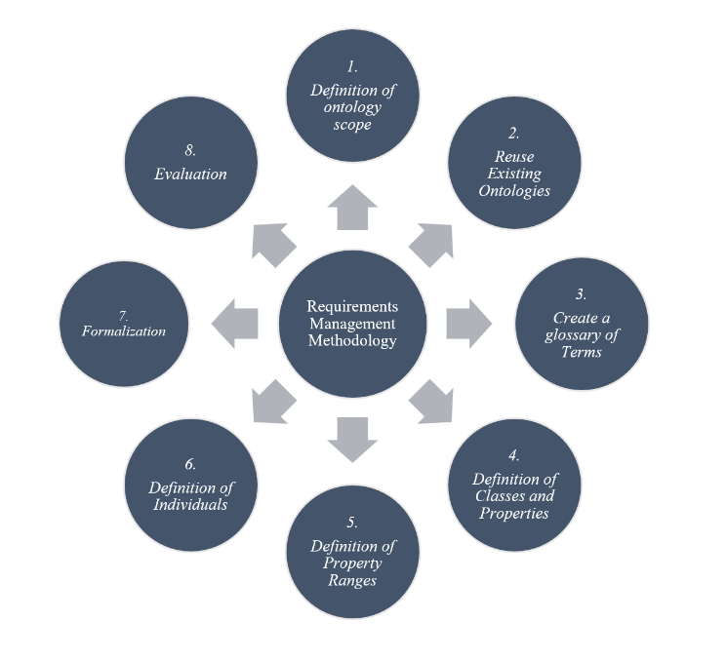

1. Resultant hybrid methodology

The processes embodied by these 8 phases are as follows:

1. *Definition of ontology scope*: In earlier iterations this serves as a preparatory phase concerned with the high-level specification of the knowledge model. This specification involves a description of the domain of interest, the high-level aims and objectives, competency questions, scope, and roles. This phase lays a foundation for subsequent phases, that helps to encompass the requirements.
2. *Reuse Existing Ontologies*: This phase encompasses research of existing ontologies in the established domain. The result of this research should determine the validity of other ontologies for their reuse. This aids in reducing costs and time, whilst also provisioning interoperability and integration of the new ontology in semantic-based applications.
3. *Create a glossary of Terms*: This phase hopes to provide a deeper understanding of the domain. Various terms will be captured from a variety of information elicitation techniques, resulting in the intended vocabulary of the domain. This phase is looked at in detail in the section below: data collection.
4. *Definition of Classes and Properties*: This phase seeks out structure across the gathered terms/vocabulary. This includes finding trends and rationalizing the anatomy of the ontology, often expressed though diagrams. This step hopes to yield the taxonomy of classes and their properties for the ontology.
5. *Definition of Property Ranges*: This phase seeks to expand on the property characteristics identified in the previous stage. This involves specifying the domain and range, value types, and cardinalities.
6. *Definition of Individuals*: This phase seeks to conclude the allocation of the remaining terms. Consequently, the class instances are created.
7. *Formalization*: This phase encodes the conceptual structure into an ontology development environment, such as Protégé. From this, various refinements are made.
8. *Evaluation*: This phase includes the testing, refinement, consistency, and completeness of the ontology. The measure of completeness and adequacy is often determined by the ontology’s ability to answer the competency questions. This marks the conclusion of the current iteration.

## Data Collection

As indicated by Fig. 1, requirements management is a core workflow to this methodology. It can be viewed as the glue that holds all the phases together. This workflow is represented by our use of a central vocabulary pool to capture the various terms in our ontology. This allowed the group to collaborate on finding various terms and keeping them managed in an autonomous manner. This was facilitated via a shared Excel spreadsheet indicated by Fig. 2 below. Upon finding a term, it was added to the spreadsheet and classified as either a class, relation or instance. Once evaluated the term would be marked as approved or discarded. The approved terms were filtered from this spreadsheet to constitute the final vocabulary of the presented ontology.

1. Snapshot of excel spreadsheet used for managing vocabulary

In gathering the data for the presented ontology, NASA were of great assistance. NASA plays a big role in disseminating explicit knowledge within the space domain, and of particular help were NASA’s planetary, comet, and asteroid fact sheets[17]–[19] which assisted in gathering terms amongst their other resources.

Also of particular help were the two reviewed ontologies[5], [7]. This helped in mostly the structuring of the ontology, but also aided in identifying a small subset of terms.

With the abundance of space literature, through books[11], [20]–[24], conference papers[25], journal articles[5], [7], [13], [26], [27], reports[28] and websites[1]–[4], [8]–[10], [12], [14]–[19], [29]–[39], several terms were identified to populate the deliverable Celestial Body Classification Ontology.

## Formalization of Ontology

In the formalization phase of the employed methodology, the conceptual structure is encoded into a machine-readable format. The particular workflow employed in the development of this ontology was to first develop a set of natural language axioms. This was subsequently converted into its FOL and DL representations.

This process is documented through Table I-III in Section IV. The DL statements would form the basis of encoding the ontology into its final OWL2 knowledge presentation language format.

# Modeling of Ontology

## Vocabulary of the Domain

### Classes:

1. CelestialCluster
2. CelestialBody
3. Comet
4. Asteroid
5. Star
6. Planet
7. Satellite
8. BlackHole
9. PeriodicComet
10. NonPeriodicComet
11. SungrazingComet
12. LostComet
13. TypeCAsteroid
14. TypeSAsteroid
15. TypeMAsteroid
16. ClassOStar
17. ClassBStar
18. ClassAStar
19. ClassFStar
20. ClassGStar
21. ClassKStar
22. ClassMStar
23. TerrestrialPlanet
24. GaseousPlanet
25. NaturalSatellite
26. ArtificialSatellite
27. StellarBlackHole
28. IntermediateBlackHole
29. SupermassiveBlackHole
30. MinitatureBlackHole
31. IntangibleCometProperty
32. TangibleCometProperty
33. CometCharacteristic
34. IntangibleAsteroidProperty
35. TangibleAsteroidProperty
36. AsteroidCharacteristic
37. IntangibleStarProperty
38. TangibleStarProperty
39. StarCharacteristic
40. IntangiblePlanetProperty
41. TangiblePlanetProperty
42. PlanetCharacteristic
43. IntangibleSatelliteProperty
44. TangibleSatelliteProperty
45. SateliteCharacteristic
46. IntangibleBlackHoleProperty
47. TangibleBlackHoleProperty
48. BlackHoleCharacteristic
49. IntangibleCelestialBodyPropety
50. TangibleCelestialBodyProperty
51. CelestialBodyCharacteristic
52. Temperature
53. SolarCycle
54. DayLength
55. Mass
56. Density
57. MeteorShower
58. AtmosphereElement
59. SurfaceMaterial
60. CoreMaterial
61. Tsunami
62. Rain
63. Storm
64. VolcanicEruption
65. Tornado
66. AtmosphereLayer
67. RadiationLevel
68. GeothermalStorm
69. PartialLunarEclipse
70. FullLunarEclipse
71. RingMaterial
72. RingWidth
73. AvgWaterPH
74. Gravity
75. GravityStrength
76. AtmosphePressure
77. RotationAngle
78. MagneticField
79. MagneticFieldStrength
80. ProducibleElement
81. SignalTransmission
82. OrbitalPeriod
83. Lifespan
84. FormationEvent
85. RadiationType
86. HabitableZone
87. SurfaceLayer
88. ClimateRegion
89. Atmosphere
90. SurfaceTemperature
91. Radius
92. Speed
93. Shape
94. WindSpeed
95. Surface
96. Core
97. Ring
98. NaturalEvent
99. WaterBody
100. SolarNebula
101. Colour
102. SolarStorm
103. SolarFlare
104. StellarWind
105. Particle

### Properties

1. hasIntangibleCometProperty
2. hasTangibleCometProperty
3. hasCometCharacteristic
4. hasIntangibleAsteroidProperty
5. hasTangibleAsteroidProperty
6. hasAsteroidCharacteristic
7. hasIntangibleStarProperty
8. hasTangibleStarProperty
9. hasStarCharacteristic
10. hasIntangiblePlanetProperty
11. hasTangiblePlanetProperty
12. hasPlanetCharacteristic
13. hasIntangibleSatelliteProperty
14. hasTangibleSatelliteProperty
15. hasSateliteCharacteristic
16. hasIntangibleBlackHoleProperty
17. hasTangibleBlackHoleProperty
18. hasBlackHoleCharacteristic
19. hasIntangibleCelestialBodyPropety
20. hasTangibleCelestialBodyProperty
21. hasCelestialBodyCharacteristic
22. orbits
23. feedsOff
24. experinces
25. compriseOf
26. contains
27. radiates
28. produces
29. allowsFor
30. isA
31. formedFrom
32. filters
33. hasSurfaceTemperature
34. hasAtmosphereLayer
35. hasRingWidth
36. hasAvgWaterPH
37. hasGravityStrength
38. hasAtmopsherePressure
39. hasMagneticFieldStrength
40. emits
41. hasSurfaceLayer
42. hasClimateRegion
43. hasSurfacePressure

### Instances:

1. Visited
2. Terraformable
3. Crop Life Sustaining
4. Human Life Sustaining
5. Self-Illuminating
6. Mercury
7. Venus
8. Earth
9. Mars
10. Jupiter
11. Saturn
12. Uranus
13. Neptune
14. Pluto
15. Sun
16. Moon
17. Deimos
18. Phobos
19. Amalthea
20. Calisto
21. Europa
22. Ganymede
23. Io
24. Dione
25. Enceladus
26. Hyperion
27. Iapetus
28. Mimas
29. Phoebe
30. Rhea
31. Tethys
32. Titan
33. Ariel
34. Miranda
35. Oberon
36. Titania
37. Umbriel
38. Nereid
39. Triton
40. Charon
41. Hydrogen
42. Helium
43. Oxygen
44. Carbon
45. Discovered
46. Ice
47. Dust Particle
48. Rock
49. Silica Rock
50. Dust
51. Basalt
52. Olivine
53. Pyroxene
54. Plagioclase
55. Andesite
56. Sulphate
57. Lithium
58. Silicon
59. Iron
60. Nickel
61. Siderophile
62. Sulphur
63. Halley’s Comet
64. Ton 6189
65. Kepler
66. Charged Particle
67. Energised Particle
68. ELF
69. VLF
70. Radio Wave
71. Microwave
72. Infrared
73. Visible Light
74. X-Ray
75. Gamma Ray
76. C/1980 E1
77. Kreutz
78. Biela's Comet
79. Cygnus X-1
80. GCIRS 13E
81. Four-Wire Transmission
82. Two-Wire Transmission
83. Smart Transmission
84. Fieldbus Transmission
85. Sphere
86. Oblate spheroid
87. Triaxial ellipsoid
88. Yellow
89. Orange
90. Red
91. Pink
92. Purple
93. Blue
94. Green
95. Zeta Orionis Aa
96. Regulus and Algol A
97. Altair A7 V
98. Polaris
99. Alpha Centauri B
100. Betelgeuse
101. Hygiea
102. Eunomia
103. Psyche
104. Tropical Climate
105. Dry Climate
106. Subtropical Climate
107. Continental Climate
108. Polar Climate
109. Highlands Climate

## List of Axioms of the Domain

1. Axioms of the Domain

|  |  |
| --- | --- |
| **No.** | **Axioms** |
| 1. | A Celestial Cluster contains one or more Celestial Bodies |
| 2. | Comet is a Celestial Body |
| 3. | Asteroid is a Celestial Body |
| 4. | Star is a Celestial Body |
| 5. | Planet is a Celestial Body |
| 6. | Satellite is a Celestial Body |
| 7. | Black Hole is a Celestial Body |
| 8. | Periodic Comet is a Comet |
| 9. | Nonperiodic Comet is a Comet |
| 10. | Sungrazing Comet is a Comet |
| 11. | Lost Comet is a Comet |
| 12. | Type-C Asteroid is an Asteroid |
| 13. | Type-S Asteroid is an Asteroid |
| 14. | Type-M Asteroid is an Asteroid |
| 15. | Class-O Star is a Star |
| 16. | Class-B Star is a Star |
| 17. | Class-A Star is Star |
| 18. | Class-F Star is a Star |
| 19. | Class-G Star is a Star |
| 20. | Class-K Star is a Star |
| 21. | Class-M Star is a Star |
| 22. | Terrestrial Planet is a Planet |
| 23. | Gaseous Planet is a Planet |
| 24. | Natural Satellite is a Satellite |
| 25. | Artificial Satellite is a Satellite |
| 26. | Stellar Black Hole is a Black Hole |
| 27. | Intermediate Black Hole is a Black Hole |
| 28. | Supermassive Black Hole is a Black Hole |
| 29. | Miniature Black Hole is a Black Hole |
| 30. | A Comet has one or more Intangible Comet Properties |
| 31. | A Comet has one or more Tangible Comet Properties |
| 32. | A Comet has one or more Comet Characteristics |
| 33. | An Asteroid has one or more Intangible Asteroid Properties |
| 34. | An Asteroid has one or more Tangible Asteroid Properties |
| 35. | An Asteroid has one or more Asteroid Characteristics |
| 36. | A Star has one or more Intangible Star Properties |
| 37. | A Star has one or more Tangible Star Properties |
| 38. | A Star has one or more Star Characteristics |
| 39. | A Planet has one or more Intangible Planet Properties |
| 40. | A Planet has one or more Tangible Planet Properties |
| 41. | A Planet has one or more Planet Characteristics |
| 42. | A Satellite has one or more Intangible Satellite Properties |
| 43. | A Satellite has one or more Tangible Satellite Properties |
| 44. | A Satellite has one or more Satellite Characteristics |
| 45. | A Black Hole has one or more Intangible Black Hole Properties |
| 46. | A Black Hole has one or more Tangible Black Hole Properties |
| 47. | A Black Hole has one or more Black Hole Characteristics |
| 48. | A Celestial Body has one or more Intangible Celestial Body Properties |
| 49. | A Celestial Body has one or more Tangible Celestial Body Properties |
| 50. | A Celestial Body has one or more Celestial Body Characteristics |
| 51. | Mercury is a Terrestrial Planet |
| 52. | Venus is a Terrestrial Planet |
| 53. | Earth is a Terrestrial Planet |
| 54. | Mars is a Terrestrial Planet |
| 55. | Jupiter is a Gaseous Planet |
| 56. | Saturn is a Gaseous Planet |
| 57. | Uranus is a Gaseous Planet |
| 58. | Neptune is a Gaseous Planet |
| 59. | Pluto is a Terrestrial Planet |
| 60. | Moon is a Natural Satellite |
| 61. | Deimos is a Natural Satellite |
| 62. | Phobos is a Natural Satellite |
| 63. | Amalthea is a Natural Satellite |
| 64. | Calisto is a Natural Satellite |
| 65. | Europa is a Natural Satellite |
| 66. | Ganymede is a Natural Satellite |
| 67. | Io is a Natural Satellite |
| 68. | Dione is a Natural Satellite |
| 69. | Enceladus is a Natural Satellite |
| 70. | Hyperion is a Natural Satellite |
| 71. | Iapetus is a Natural Satellite |
| 72. | Mimas is a Natural Satellite |
| 73. | Phoebe is a Natural Satellite |
| 74. | Rhea is a Natural Satellite |
| 75. | Tethys is a Natural Satellite |
| 76. | Titan is a Natural Satellite |
| 77. | Ariel is a Natural Satellite |
| 78. | Miranda is a Natural Satellite |
| 79. | Oberon is a Natural Satellite |
| 80. | Titania is a Natural Satellite |
| 81. | Umbriel is a Natural Satellite |
| 82. | Nereid is a Natural Satellite |
| 83. | Triton is a Natural Satellite |
| 84. | Charon is a Natural Satellite |
| 85. | Hydrogen is an Atmospheric Element |
| 86. | Helium is an Atmospheric Element |
| 87. | Oxygen is an Atmospheric Element |
| 88. | Carbon is an Atmospheric Element |
| 89. | Visited is a Celestial Body Characteristic |
| 90. | Terraformable is a Planet Characteristic |
| 91. | Terraformable is a Satellite Characteristic |
| 92. | Crop Life Sustaining is a Planet Characteristic |
| 93. | Crop Life Sustaining is a Satellite Characteristic |
| 94. | Human Life Sustaining is a Planet Characteristic |
| 95. | Human Life Sustaining is a Satellite Characteristic |
| 96. | Self-Illuminating is a Celestial Body Characteristic |
| 97. | Discovered is a Celestial Body Characteristic |
| 98. | Temperature is an Intangible Celestial Body Property |
| 99. | Solar Cycle is an Intangible Star Property |
| 100. | Atmosphere is a Tangible Star Property |
| 101. | Atmosphere is a Tangible Planet Property |
| 102. | Atmosphere is a Tangible Comet Property |
| 103. | Atmosphere is a Tangible Asteroid Property |
| 104. | Atmosphere is a Tangible Satellite Property |
| 105. | Radius is a Planet Intangible Planet Property |
| 106. | Radius is an Intangible Star Property |
| 107. | Radius is an Intangible Comet Property |
| 108. | Radius is an Intangible Asteroid Property |
| 109. | Radius is an Intangible Satellite Property |
| 110. | Radius is an Intangible Black Hole Property |
| 111. | Speed is an Intangible Comet Property |
| 112. | Speed is an Intangible Asteroid Property |
| 113. | Speed is an Intangible Satellite Property |
| 114. | Day Length is an Intangible Planet Property |
| 115. | Day Length is an Intangible Satellite Property |
| 116. | Mass is an Intangible Celestial Body Property |
| 117. | Density is an Intangible Celestial Body Property |
| 118. | Wind Speed is an Intangible Planet Property |
| 119. | Wind Speed is an Intangible Satellite Property |
| 120. | A Planet experiences one or more Natural Events |
| 121. | A Star experiences one or more Natural Events |
| 122. | A Natural Satellite experiences one or more Natural Events |
| 123. | Tsunami is a Natural Event |
| 124. | Rain is a Natural Event |
| 125. | Storm is a Natural Event |
| 126. | Volcanic Eruptions is a Natural Event |
| 127. | Tornado is a Natural Event |
| 128. | Geothermal Storm is a Storm |
| 129. | Meteor Showers is a Natural Event |
| 130. | An Atmosphere comprises of one or more Atmosphere Elements |
| 131. | Surface is a Tangible Planet Property |
| 132. | Surface is a Tangible Star Property |
| 133. | Surface is a Tangible Comet Property |
| 134. | Surface is a Tangible Satellite Property |
| 135. | Surface is a Tangible Asteroid Property |
| 136. | A surface is comprised of one or more Surface Materials |
| 137. | A surface has a Surface Temperature |
| 138. | Core is a Tangible Planet Property |
| 139. | Core is a Tangible Star Property |
| 140. | Core is a Tangible Comet Property |
| 141. | Core is a TangibleSatellite Property |
| 142. | Each Core is comprised of one or more Core Materials |
| 143. | An Atmosphere has one or more Atmosphere Layers |
| 144. | Radiation Level is an Intangible Celestial Body Property |
| 145. | Ring is a Tangible Planet Property |
| 146. | Ring is a Tangible Star Property |
| 147. | Ring is a Tangible Satellite Property |
| 148. | A Ring is comprised of Ring Materials |
| 149. | Each Ring has a Ring Width |
| 150. | A Planet contains zero or more Waterbodies |
| 151. | A Natural Satellite contains zero or more Waterbodies |
| 152. | A Comet contains zero or more Waterbodies |
| 153. | A Water Body has a Water PH |
| 154. | Gravity is an Intangible Celestial Body Property |
| 155. | Gravity has a Gravity Strength |
| 156. | An Atmosphere has an Atmospheric Pressure |
| 157. | Rotation Angle is an Intangible Celestial Body Property |
| 158. | Magnetic Field is a Tangible Celestial Body Property |
| 159. | Each Magnetic Field has a Magnetic Field Strength |
| 160. | A Star produces one or more Producible Elements |
| 161. | An Artificial Satellite allows for Signal Transmission |
| 162. | Orbital Period is an Intangible Celestial Body Property |
| 163. | Lifespan is an Intangible Celestial Body Property |
| 164. | A Celestial Body is formed from a Formation Event |
| 165. | A Celestial Body radiates a Radiation Type |
| 166. | A star emits one or more Particles |
| 167. | A Black Hole feeds off zero or more other Celestial Bodies |
| 168. | Habitable Zone is an Intangible Star Property |
| 169. | Shape is a Tangible Celestial Body Property |
| 170. | A Surface has one or more Surface Layers |
| 171. | A Planet has one or more Climactic Regions |
| 172. | Colour is a Tangible Celestial Body Property |
| 173. | Charged Particle is a Particle |
| 174. | Energized Particle is a Particle |
| 175. | An Atmosphere filters zero or more Radiation Types |
| 176. | ELF is a Radiation Type |
| 177. | VLF is a Radiation Type |
| 178. | Radio waves is a Radiation Type |
| 179. | Microwaves is a Radiation Type |
| 180. | Infrared is a Radiation Type |
| 181. | Visible Light is a Radiation Type |
| 182. | X-Ray is a Radiation Type |
| 183. | Gamma Ray is a Radiation Type |
| 184. | Ice is a Ring Material |
| 185. | Dust Particle is a Ring Material |
| 186. | Rock is a Ring Material |
| 187. | Silica Rock is a Surface Material |
| 188. | Dust is a Surface Material |
| 189. | Basalt is a Surface Material |
| 190. | Olivine is a Surface Material |
| 191. | Pyroxene is a Surface Material |
| 192. | Andesite is a Surface Material |
| 193. | Sulphate is a Surface Material |
| 194. | Solar Nebula is a Formation Event |
| 195. | Solar Storm is a Storm |
| 196. | Solar Flare is a Natural Event |
| 197. | Partial Lunar Eclipse is a Natural Event |
| 198. | Full Lunar Eclipse is a Natural Event |
| 199. | Stellar Wind is a Natural Event |
| 200. | Hydrogen is a Producible Element |
| 201. | Helium is a Producible Element |
| 202. | Silicon is a Producible Element |
| 203. | Lithium is a Producible Element |
| 204. | Iron is a Core Material |
| 205. | Nickel is a Core Material |
| 206. | Sulphur is a Core Material |
| 207. | Siderophile is a Core Material |
| 208. | A Celestial Body orbits zero or more other Celestial Bodies |
| 209. | Moon orbits Earth |
| 210. | Deimos orbits Mars |
| 211. | Phobos orbits Mars |
| 212. | Amalthea orbits Jupiter |
| 213. | Calisto orbits Jupiter |
| 214. | Europa orbits Jupiter |
| 215. | Ganymede orbits Jupiter |
| 216. | Io orbits Jupiter |
| 217. | Dione orbits Saturn |
| 218. | Enceladus orbits Saturn |
| 219. | Hyperion orbits Saturn |
| 220. | Iapetus orbits Saturn |
| 221. | Mimas orbits Saturn |
| 222. | Phoebe orbits Saturn |
| 223. | Rhea orbits Saturn |
| 224. | Tethys orbits Saturn |
| 225. | Titan orbits Saturn |
| 226. | Ariel orbits Uranus |
| 227. | Miranda orbits Uranus |
| 228. | Oberon orbits Uranus |
| 229. | Titania orbits Uranus |
| 230. | Umbriel orbits Uranus |
| 231. | Nereid orbits Neptune |
| 232. | Triton orbits Neptune |
| 233. | Charon orbits Pluto |
| 234. | Mercury orbits the Sun |
| 235. | Venus orbits the Sun |
| 236. | Earth orbits the Sun |
| 237. | Mars orbits the Sun |
| 238. | Jupiter orbits the Sun |
| 239. | Saturn orbits the Sun |
| 240. | Uranus orbits the Sun |
| 241. | Neptune orbits the Sun |
| 242. | Pluto orbits the Sun |
| 243. | Halley’s Comet is a Periodic Comet |
| 244. | C/1980 E1 is a Non-periodic Comet |
| 245. | Kreutz is a Sungrazing Comet |
| 246. | Biela's Comet is a Lost Comet |
| 247. | Ton 618 is a Supermassive Black Hole |
| 248. | Cygnus X-1 is a Stellar Black Hole |
| 249. | GCIRS 13E is an Intermediate Black Hole |
| 250. | Kepler is an Artificial Satellite |
| 251. | The Sun is a Class-G Star |
| 252. | Four-Wire Transmission is a Signal Transmission |
| 253. | Two-Wire Transmission is a Signal Transmission |
| 254. | Smart Transmission is a Signal Transmission |
| 255. | Fieldbus Transmission is a Signal Transmission |
| 256. | Sphere is a Shape |
| 257. | Oblate spheroid is a Shape |
| 258. | Triaxial ellipsoid is a Shape |
| 259. | A Surface has a Surface Pressure |
| 260. | Yellow is a Colour |
| 261. | Orange is a Colour |
| 262. | Red is a Colour |
| 263. | Pink is a Colour |
| 264. | Purple is a Colour |
| 265. | Blue is a Colour |
| 266. | Green is a Colour |
| 267. | Zeta Orionis Aa is a Class-O Star |
| 268. | Regulus and Algol A is a Class-B Star |
| 269. | Altair A7 V is a Class-A Star |
| 270. | Polaris is a Class-F Star |
| 271. | Alpha Centauri B is a Class-K Star |
| 272. | Betelgeuse is a Class-M Star |
| 273. | Hygiea is a Type-C Asteroid |
| 274. | Eunomia is a Type-S Asteroid |
| 275. | Psyche is a Type-M Asteroid |
| 276. | Tropical Climate is a Climate Region |
| 277. | Dry Climate is a Climate Region |
| 278. | Subtropical Climate is a Climate Region |
| 279. | Continental Climate is a Climate Region |
| 280. | Polar Climate is a Climate Region |
| 281. | Highlands is a Climate Region |

## FOL Represenation of the Domain

1. First Order Logic Representation

|  |  |  |
| --- | --- | --- |
| **No.** | **Representation** | |
| ***Axiom*** | ***First Order Logic*** |
| 1. | A Celestial Cluster contains one or more Celestial Bodies | $$∀x( CelestialCluster\left(x\right) → ∃y(CelesialBody\left(y\right)⋀contains\left(x,y\right)) )$$ |
| 2. | Comet is a Celestial Body | $$∀x( Comet\left(x\right) →CelestialBody\left(x\right) )$$ |
| 3. | Asteroid is a Celestial Body |  |
| 4. | Star is a Celestial Body |  |
| 5. | Planet is a Celestial Body |  |
| 6. | Satellite is a Celestial Body |  |
| 7. | Black Hole is a Celestial Body |  |
| 8. | Periodic Comet is a Comet |  |
| 9. | Nonperiodic Comet is a Comet |  |
| 10. | Sungrazing Comet is a Comet |  |
| 11. | Lost Comet is a Comet |  |
| 12. | Type-C Asteroid is an Asteroid |  |
| 13. | Type-S Asteroid is an Asteroid |  |
| 14. | Type-M Asteroid is an Asteroid |  |
| 15. | Class-O Star is a Star |  |
| 16. | Class-B Star is a Star |  |
| 17. | Class-A Star is Star |  |
| 18. | Class-F Star is a Star |  |
| 19. | Class-G Star is a Star |  |
| 20. | Class-K Star is a Star |  |
| 21. | Class-M Star is a Star |  |
| 22. | Terrestrial Planet is a Planet |  |
| 23. | Gaseous Planet is a Planet |  |
| 24. | Natural Satellite is a Satellite |  |
| 25. | Artificial Satellite is a Satellite |  |
| 26. | Stellar Black Hole is a Black Hole |  |
| 27. | Intermediate Black Hole is a Black Hole |  |
| 28. | Supermassive Black Hole is a Black Hole |  |
| 29. | Miniature Black Hole is a Black Hole |  |
| 30. | A Comet has one or more Intangible Comet Properties |  |
| 31. | A Comet has one or more Tangible Comet Properties |  |
| 32. | A Comet has one or more Comet Characteristics |  |
| 33. | An Asteroid has one or more Intangible Asteroid Properties |  |
| 34. | An Asteroid has one or more Tangible Asteroid Properties |  |
| 35. | An Asteroid has one or more Asteroid Characteristics |  |
| 36. | A Star has one or more Intangible Star Properties |  |
| 37. | A Star has one or more Tangible Star Properties |  |
| 38. | A Star has one or more Star Characteristics |  |
| 39. | A Planet has one or more Intangible Planet Properties |  |
| 40. | A Planet has one or more Tangible Planet Properties |  |
| 41. | A Planet has one or more Planet Characteristics |  |
| 42. | A Satellite has one or more Intangible Satellite Properties |  |
| 43. | A Satellite has one or more Tangible Satellite Properties |  |
| 44. | A Satellite has one or more Satellite Characteristics |  |
| 45. | A Black Hole has one or more Intangible Black Hole Properties |  |
| 46. | A Black Hole has one or more Tangible Black Hole Properties |  |
| 47. | A Black Hole has one or more Black Hole Characteristics |  |
| 48. | A Celestial Body has one or more Intangible Celestial Body Properties |  |
| 49. | A Celestial Body has one or more Tangible Celestial Body Properties |  |
| 50. | A Celestial Body has one or more Celestial Body Characteristics |  |
| 51. | Mercury is a Terrestrial Planet |  |
| 52. | Venus is a Terrestrial Planet |  |
| 53. | Earth is a Terrestrial Planet |  |
| 54. | Mars is a Terrestrial Planet |  |
| 55. | Jupiter is a Gaseous Planet |  |
| 56. | Saturn is a Gaseous Planet |  |
| 57. | Uranus is a Gaseous Planet |  |
| 58. | Neptune is a Gaseous Planet |  |
| 59. | Pluto is a Terrestrial Planet |  |
| 60. | Moon is a Natural Satellite |  |
| 61. | Deimos is a Natural Satellite |  |
| 62. | Phobos is a Natural Satellite |  |
| 63. | Amalthea is a Natural Satellite |  |
| 64. | Calisto is a Natural Satellite |  |
| 65. | Europa is a Natural Satellite |  |
| 66. | Ganymede is a Natural Satellite |  |
| 67. | Io is a Natural Satellite |  |
| 68. | Dione is a Natural Satellite |  |
| 69. | Enceladus is a Natural Satellite |  |
| 70. | Hyperion is a Natural Satellite |  |
| 71. | Iapetus is a Natural Satellite |  |
| 72. | Mimas is a Natural Satellite |  |
| 73. | Phoebe is a Natural Satellite |  |
| 74. | Rhea is a Natural Satellite |  |
| 75. | Tethys is a Natural Satellite |  |
| 76. | Titan is a Natural Satellite |  |
| 77. | Ariel is a Natural Satellite |  |
| 78. | Miranda is a Natural Satellite |  |
| 79. | Oberon is a Natural Satellite |  |
| 80. | Titania is a Natural Satellite |  |
| 81. | Umbriel is a Natural Satellite |  |
| 82. | Nereid is a Natural Satellite |  |
| 83. | Triton is a Natural Satellite |  |
| 84. | Charon is a Natural Satellite |  |
| 85. | Hydrogen is an Atmospheric Element |  |
| 86. | Helium is an Atmospheric Element |  |
| 87. | Oxygen is an Atmospheric Element |  |
| 88. | Carbon is an Atmospheric Element |  |
| 89. | Visited is a Celestial Body Characteristic |  |
| 90. | Terraformable is a Planet Characteristic |  |
| 91. | Terraformable is a Satellite Characteristic |  |
| 92. | Crop Life Sustaining is a Planet Characteristic |  |
| 93. | Crop Life Sustaining is a Satellite Characteristic |  |
| 94. | Human Life Sustaining is a Planet Characteristic |  |
| 95. | Human Life Sustaining is a Satellite Characteristic |  |
| 96. | Self-Illuminating is a Celestial Body Characteristic |  |
| 97. | Discovered is a Celestial Body Characteristic |  |
| 98. | Temperature is an Intangible Celestial Body Property |  |
| 99. | Solar Cycle is an Intangible Star Property |  |
| 100. | Atmosphere is a Tangible Star Property |  |
| 101. | Atmosphere is a Tangible Planet Property |  |
| 102. | Atmosphere is a Tangible Comet Property |  |
| 103. | Atmosphere is a Tangible Asteroid Property |  |
| 104. | Atmosphere is a Tangible Satellite Property |  |
| 105. | Radius is a Planet Intangible Planet Property |  |
| 106. | Radius is an Intangible Star Property |  |
| 107. | Radius is an Intangible Comet Property |  |
| 108. | Radius is an Intangible Asteroid Property |  |
| 109. | Radius is an Intangible Satellite Property |  |
| 110. | Radius is an Intangible Black Hole Property |  |
| 111. | Speed is an Intangible Comet Property |  |
| 112. | Speed is an Intangible Asteroid Property |  |
| 113. | Speed is an Intangible Satellite Property |  |
| 114. | Day Length is an Intangible Planet Property |  |
| 115. | Day Length is an Intangible Satellite Property |  |
| 116. | Mass is an Intangible Celestial Body Property |  |
| 117. | Density is an Intangible Celestial Body Property |  |
| 118. | Wind Speed is an Intangible Planet Property |  |
| 119. | Wind Speed is an Intangible Satellite Property |  |
| 120. | A Planet experiences one or more Natural Events |  |
| 121. | A Star experiences one or more Natural Events |  |
| 122. | A Natural Satellite experiences one or more Natural Events |  |
| 123. | Tsunami is a Natural Event |  |
| 124. | Rain is a Natural Event |  |
| 125. | Storm is a Natural Event |  |
| 126. | Volcanic Eruptions is a Natural Event |  |
| 127. | Tornado is a Natural Event |  |
| 128. | Geothermal Storm is a Storm |  |
| 129. | Meteor Showers is a Natural Event |  |
| 130. | An Atmosphere comprises of one or more Atmosphere Elements |  |
| 131. | Surface is a Tangible Planet Property |  |
| 132. | Surface is a Tangible Star Property |  |
| 133. | Surface is a Tangible Comet Property |  |
| 134. | Surface is a Tangible Satellite Property |  |
| 135. | Surface is a Tangible Asteroid Property |  |
| 136. | A surface is comprised of one or more Surface Materials |  |
| 137. | A surface has a Surface Temperature |  |
| 138. | Core is a Tangible Planet Property |  |
| 139. | Core is a Tangible Star Property |  |
| 140. | Core is a Tangible Comet Property |  |
| 141. | Core is a TangibleSatellite Property |  |
| 142. | Each Core is comprised of one or more Core Materials |  |
| 143. | An Atmosphere has one or more Atmosphere Layers |  |
| 144. | Radiation Level is an Intangible Celestial Body Property |  |
| 145. | Ring is a Tangible Planet Property |  |
| 146. | Ring is a Tangible Star Property |  |
| 147. | Ring is a Tangible Satellite Property |  |
| 148. | A Ring is comprised of Ring Materials |  |
| 149. | Each Ring has a Ring Width |  |
| 150. | A Planet contains zero or more Waterbodies |  |
| 151. | A Natural Satellite contains zero or more Waterbodies |  |
| 152. | A Comet contains zero or more Waterbodies |  |
| 153. | A Water Body has a Water PH |  |
| 154. | Gravity is an Intangible Celestial Body Property |  |
| 155. | Gravity has a Gravity Strength |  |
| 156. | An Atmosphere has an Atmospheric Pressure |  |
| 157. | Rotation Angle is an Intangible Celestial Body Property |  |
| 158. | Magnetic Field is a Tangible Celestial Body Property |  |
| 159. | Each Magnetic Field has a Magnetic Field Strength |  |
| 160. | A Star produces one or more Producible Elements |  |
| 161. | An Artificial Satellite allows for Signal Transmission |  |
| 162. | Orbital Period is an Intangible Celestial Body Property |  |
| 163. | Lifespan is an Intangible Celestial Body Property |  |
| 164. | A Celestial Body is formed from a Formation Event |  |
| 165. | A Celestial Body radiates a Radiation Type |  |
| 166. | A star emits one or more Particles |  |
| 167. | A Black Hole feeds off zero or more other Celestial Bodies |  |
| 168. | Habitable Zone is an Intangible Star Property |  |
| 169. | Shape is a Tangible Celestial Body Property |  |
| 170. | A Surface has one or more Surface Layers |  |
| 171. | A Planet has one or more Climatic Regions |  |
| 172. | Colour is a Tangible Celestial Body Property |  |
| 173. | Charged Particle is a Particle |  |
| 174. | Energised Particle is a Particle |  |
| 175. | An Atmosphere filters zero or more Radiation Types |  |
| 176. | ELF is a Radiation Type |  |
| 177. | VLF is a Radiation Type |  |
| 178. | Radio waves is a Radiation Type |  |
| 179. | Microwaves is a Radiation Type |  |
| 180. | Infrared is a Radiation Type |  |
| 181. | Visible Light is a Radiation Type |  |
| 182. | X-Ray is a Radiation Type |  |
| 183. | Gamma Ray is a Radiation Type |  |
| 184. | Ice is a Ring Material |  |
| 185. | Dust Particle is a Ring Material |  |
| 186. | Rock is a Ring Material |  |
| 187. | Silica Rock is a Surface Material |  |
| 188. | Dust is a Surface Material |  |
| 189. | Basalt is a Surface Material |  |
| 190. | Olivine is a Surface Material |  |
| 191. | Pyroxene is a Surface Material |  |
| 192. | Andesite is a Surface Material |  |
| 193. | Sulphate is a Surface Material |  |
| 194. | Solar Nebula is a Formation Event |  |
| 195. | Solar Storm is a Storm |  |
| 196. | Solar Flare is a Natural Event |  |
| 197. | Partial Lunar Eclipse is a Natural Event |  |
| 198. | Full Lunar Eclipse is a Natural Event |  |
| 199. | Stellar Wind is a Natural Event |  |
| 200. | Hydrogen is a Producible Element |  |
| 201. | Helium is a Producible Element |  |
| 202. | Silicon is a Producible Element |  |
| 203. | Lithium is a Producible Element |  |
| 204. | Iron is a Core Material |  |
| 205. | Nickel is a Core Material |  |
| 206. | Sulphur is a Core Material |  |
| 207. | Siderophile is a Core Material |  |
| 208. | A Celestial Body orbits zero or more other Celestial Bodies |  |
| 209. | Moon orbits Earth |  |
| 210. | Deimos orbits Mars |  |
| 211. | Phobos orbits Mars |  |
| 212. | Amalthea orbits Jupiter |  |
| 213. | Calisto orbits Jupiter |  |
| 214. | Europa orbits Jupiter |  |
| 215. | Ganymede orbits Jupiter |  |
| 216. | Io orbits Jupiter |  |
| 217. | Dione orbits Saturn |  |
| 218. | Enceladus orbits Saturn |  |
| 219. | Hyperion orbits Saturn |  |
| 220. | Iapetus orbits Saturn |  |
| 221. | Mimas orbits Saturn |  |
| 222. | Phoebe orbits Saturn |  |
| 223. | Rhea orbits Saturn |  |
| 224. | Tethys orbits Saturn |  |
| 225. | Titan orbits Saturn |  |
| 226. | Ariel orbits Uranus |  |
| 227. | Miranda orbits Uranus |  |
| 228. | Oberon orbits Uranus |  |
| 229. | Titania orbits Uranus |  |
| 230. | Umbriel orbits Uranus |  |
| 231. | Nereid orbits Neptune |  |
| 232. | Triton orbits Neptune |  |
| 233. | Charon orbits Pluto |  |
| 234. | Mercury orbits the Sun |  |
| 235. | Venus orbits the Sun |  |
| 236. | Earth orbits the Sun |  |
| 237. | Mars orbits the Sun |  |
| 238. | Jupiter orbits the Sun |  |
| 239. | Saturn orbits the Sun |  |
| 240. | Uranus orbits the Sun |  |
| 241. | Neptune orbits the Sun |  |
| 242. | Pluto orbits the Sun |  |
| 243. | Halley’s Comet is a Periodic Comet |  |
| 244. | C/1980 E1 is a Non-periodic Comet |  |
| 245. | Kreutz is a Sungrazing Comet |  |
| 246. | Biela's Comet is a Lost Comet |  |
| 247. | Ton 618 is a Supermassive Black Hole |  |
| 248. | Cygnus X-1 is a Stellar Black Hole |  |
| 249. | GCIRS 13E is an Intermediate Black Hole |  |
| 250. | Kepler is an Artificial Satellite |  |
| 251. | The Sun is a Class-G Star |  |
| 252. | Four-Wire Transmission is a Signal Transmission |  |
| 253. | Two-Wire Transmission is a Signal Transmission |  |
| 254. | Smart Transmission is a Signal Transmission |  |
| 255. | Fieldbus Transmission is a Signal Transmission |  |
| 256. | Sphere is a Shape |  |
| 257. | Oblate spheroid is a Shape |  |
| 258. | Triaxial ellipsoid is a Shape |  |
| 259. | A Surface has a Surface Pressure |  |
| 260. | Yellow is a Colour |  |
| 261. | Orange is a Colour |  |
| 262. | Red is a Colour |  |
| 263. | Pink is a Colour |  |
| 264. | Purple is a Colour |  |
| 265. | Blue is a Colour |  |
| 266. | Green is a Colour |  |
| 267. | Zeta Orionis Aa is a Class-O Star |  |
| 268. | Regulus and Algol A is a Class-B Star |  |
| 269. | Altair A7 V is a Class-A Star |  |
| 270. | Polaris is a Class-F Star |  |
| 271. | Alpha Centauri B is a Class-K Star |  |
| 272. | Betelgeuse is a Class-M Star |  |
| 273. | Hygiea is a Type-C Asteroid |  |
| 274. | Eunomia is a Type-S Asteroid |  |
| 275. | Psyche is a Type-M Asteroid |  |
| 276. | Tropical Climate is a Climate Region |  |
| 277. | Dry Climate is a Climate Region |  |
| 278. | Subtropical Climate is a Climate Region |  |
| 279. | Continental Climate is a Climate Region | $$ClimateRegion(Continental Climate)$$ |
| 280. | Polar Climate is a Climate Region | $$ClimateRegion(Polar Climate)$$ |
| 281. | Highlands is a Climate Region | $$ClimateRegion(Highlands Climate)$$ |

## DL Representation of the Domain

1. Description Logic Representation

|  |  |  |
| --- | --- | --- |
| **No.** | **Representation** | |
| ***Axiom*** | ***Description Logic*** |
| 1. | A Celestial Cluster contains one or more Celestial Bodies | $$CelestialCluster ⊆∃contains.CelestialBody$$ |
| 2. | Comet is a Celestial Body | $$Comet ⊆CelestialBody$$ |
| 3. | Asteroid is a Celestial Body |  |
| 4. | Star is a Celestial Body |  |
| 5. | Planet is a Celestial Body |  |
| 6. | Satellite is a Celestial Body |  |
| 7. | Black Hole is a Celestial Body |  |
| 8. | Periodic Comet is a Comet |  |
| 9. | Nonperiodic Comet is a Comet |  |
| 10. | Sungrazing Comet is a Comet |  |
| 11. | Lost Comet is a Comet |  |
| 12. | Type-C Asteroid is an Asteroid |  |
| 13. | Type-S Asteroid is an Asteroid |  |
| 14. | Type-M Asteroid is an Asteroid |  |
| 15. | Class-O Star is a Star |  |
| 16. | Class-B Star is a Star |  |
| 17. | Class-A Star is Star |  |
| 18. | Class-F Star is a Star |  |
| 19. | Class-G Star is a Star |  |
| 20. | Class-K Star is a Star |  |
| 21. | Class-M Star is a Star |  |
| 22. | Terrestrial Planet is a Planet |  |
| 23. | Gaseous Planet is a Planet |  |
| 24. | Natural Satellite is a Satellite |  |
| 25. | Artificial Satellite is a Satellite |  |
| 26. | Stellar Black Hole is a Black Hole |  |
| 27. | Intermediate Black Hole is a Black Hole |  |
| 28. | Supermassive Black Hole is a Black Hole |  |
| 29. | Miniature Black Hole is a Black Hole |  |
| 30. | A Comet has one or more Intangible Comet Properties |  |
| 31. | A Comet has one or more Tangible Comet Properties |  |
| 32. | A Comet has one or more Comet Characteristics |  |
| 33. | An Asteroid has one or more Intangible Asteroid Properties |  |
| 34. | An Asteroid has one or more Tangible Asteroid Properties |  |
| 35. | An Asteroid has one or more Asteroid Characteristics |  |
| 36. | A Star has one or more Intangible Star Properties |  |
| 37. | A Star has one or more Tangible Star Properties |  |
| 38. | A Star has one or more Star Characteristics |  |
| 39. | A Planet has one or more Intangible Planet Properties |  |
| 40. | A Planet has one or more Tangible Planet Properties |  |
| 41. | A Planet has one or more Planet Characteristics |  |
| 42. | A Satellite has one or more Intangible Satellite Properties |  |
| 43. | A Satellite has one or more Tangible Satellite Properties |  |
| 44. | A Satellite has one or more Satellite Characteristics |  |
| 45. | A Black Hole has one or more Intangible Black Hole Properties |  |
| 46. | A Black Hole has one or more Tangible Black Hole Properties |  |
| 47. | A Black Hole has one or more Black Hole Characteristics |  |
| 48. | A Celestial Body has one or more Intangible Celestial Body Properties |  |
| 49. | A Celestial Body has one or more Tangible Celestial Body Properties |  |
| 50. | A Celestial Body has one or more Celestial Body Characteristics |  |
| 51. | Mercury is a Terrestrial Planet |  |
| 52. | Venus is a Terrestrial Planet |  |
| 53. | Earth is a Terrestrial Planet |  |
| 54. | Mars is a Terrestrial Planet |  |
| 55. | Jupiter is a Gaseous Planet |  |
| 56. | Saturn is a Gaseous Planet |  |
| 57. | Uranus is a Gaseous Planet |  |
| 58. | Neptune is a Gaseous Planet |  |
| 59. | Pluto is a Terrestrial Planet |  |
| 60. | Moon is a Natural Satellite |  |
| 61. | Deimos is a Natural Satellite |  |
| 62. | Phobos is a Natural Satellite |  |
| 63. | Amalthea is a Natural Satellite |  |
| 64. | Calisto is a Natural Satellite |  |
| 65. | Europa is a Natural Satellite |  |
| 66. | Ganymede is a Natural Satellite |  |
| 67. | Io is a Natural Satellite |  |
| 68. | Dione is a Natural Satellite |  |
| 69. | Enceladus is a Natural Satellite |  |
| 70. | Hyperion is a Natural Satellite |  |
| 71. | Iapetus is a Natural Satellite |  |
| 72. | Mimas is a Natural Satellite |  |
| 73. | Phoebe is a Natural Satellite |  |
| 74. | Rhea is a Natural Satellite |  |
| 75. | Tethys is a Natural Satellite |  |
| 76. | Titan is a Natural Satellite |  |
| 77. | Ariel is a Natural Satellite |  |
| 78. | Miranda is a Natural Satellite |  |
| 79. | Oberon is a Natural Satellite |  |
| 80. | Titania is a Natural Satellite |  |
| 81. | Umbriel is a Natural Satellite |  |
| 82. | Nereid is a Natural Satellite |  |
| 83. | Triton is a Natural Satellite |  |
| 84. | Charon is a Natural Satellite |  |
| 85. | Hydrogen is an Atmospheric Element |  |
| 86. | Helium is an Atmospheric Element |  |
| 87. | Oxygen is an Atmospheric Element |  |
| 88. | Carbon is an Atmospheric Element |  |
| 89. | Visited is a Celestial Body Characteristic |  |
| 90. | Terraformable is a Planet Characteristic |  |
| 91. | Terraformable is a Satellite Characteristic |  |
| 92. | Crop Life Sustaining is a Planet Characteristic |  |
| 93. | Crop Life Sustaining is a Satellite Characteristic |  |
| 94. | Human Life Sustaining is a Planet Characteristic |  |
| 95. | Human Life Sustaining is a Satellite Characteristic |  |
| 96. | Self-Illuminating is a Celestial Body Characteristic |  |
| 97. | Discovered is a Celestial Body Characteristic |  |
| 98. | Temperature is an Intangible Celestial Body Property |  |
| 99. | Solar Cycle is an Intangible Star Property |  |
| 100. | Atmosphere is a Tangible Star Property |  |
| 101. | Atmosphere is a Tangible Planet Property |  |
| 102. | Atmosphere is a Tangible Comet Property |  |
| 103. | Atmosphere is a Tangible Asteroid Property |  |
| 104. | Atmosphere is a Tangible Satellite Property |  |
| 105. | Radius is a Planet Intangible Planet Property |  |
| 106. | Radius is an Intangible Star Property |  |
| 107. | Radius is an Intangible Comet Property |  |
| 108. | Radius is an Intangible Asteroid Property |  |
| 109. | Radius is an Intangible Satellite Property |  |
| 110. | Radius is an Intangible Black Hole Property |  |
| 111. | Speed is an Intangible Comet Property |  |
| 112. | Speed is an Intangible Asteroid Property |  |
| 113. | Speed is an Intangible Satellite Property |  |
| 114. | Day Length is an Intangible Planet Property |  |
| 115. | Day Length is an Intangible Satellite Property |  |
| 116. | Mass is an Intangible Celestial Body Property |  |
| 117. | Density is an Intangible Celestial Body Property |  |
| 118. | Wind Speed is an Intangible Planet Property |  |
| 119. | Wind Speed is an Intangible Satellite Property |  |
| 120. | A Planet experiences one or more Natural Events |  |
| 121. | A Star experiences one or more Natural Events |  |
| 122. | A Natural Satellite experiences one or more Natural Events |  |
| 123. | Tsunami is a Natural Event |  |
| 124. | Rain is a Natural Event |  |
| 125. | Storm is a Natural Event |  |
| 126. | Volcanic Eruptions is a Natural Event |  |
| 127. | Tornado is a Natural Event |  |
| 128. | Geothermal Storm is a Storm |  |
| 129. | Meteor Showers is a Natural Event |  |
| 130. | An Atmosphere comprises of one or more Atmosphere Elements |  |
| 131. | Surface is a Tangible Planet Property |  |
| 132. | Surface is a Tangible Star Property |  |
| 133. | Surface is a Tangible Comet Property |  |
| 134. | Surface is a Tangible Satellite Property |  |
| 135. | Surface is a Tangible Asteroid Property |  |
| 136. | A surface is comprised of one or more Surface Materials |  |
| 137. | A surface has a Surface Temperature |  |
| 138. | Core is a Tangible Planet Property |  |
| 139. | Core is a Tangible Star Property |  |
| 140. | Core is a Tangible Comet Property |  |
| 141. | Core is a TangibleSatellite Property |  |
| 142. | Each Core is comprised of one or more Core Materials |  |
| 143. | An Atmosphere has one or more Atmosphere Layers |  |
| 144. | Radiation Level is an Intangible Celestial Body Property |  |
| 145. | Ring is a Tangible Planet Property |  |
| 146. | Ring is a Tangible Star Property |  |
| 147. | Ring is a Tangible Satellite Property |  |
| 148. | A Ring is comprised of Ring Materials |  |
| 149. | Each Ring has a Ring Width |  |
| 150. | A Planet contains zero or more Waterbodies |  |
| 151. | A Natural Satellite contains zero or more Waterbodies |  |
| 152. | A Comet contains zero or more Waterbodies |  |
| 153. | A Water Body has a Water PH |  |
| 154. | Gravity is an Intangible Celestial Body Property |  |
| 155. | Gravity has a Gravity Strength |  |
| 156. | An Atmosphere has an Atmospheric Pressure |  |
| 157. | Rotation Angle is an Intangible Celestial Body Property |  |
| 158. | Magnetic Field is a Tangible Celestial Body Property |  |
| 159. | Each Magnetic Field has a Magnetic Field Strength |  |
| 160. | A Star produces one or more Producible Elements |  |
| 161. | An Artificial Satellite allows for Signal Transmission |  |
| 162. | Orbital Period is an Intangible Celestial Body Property |  |
| 163. | Lifespan is an Intangible Celestial Body Property |  |
| 164. | A Celestial Body is formed from a Formation Event |  |
| 165. | A Celestial Body radiates a Radiation Type |  |
| 166. | A star emits one or more Particles |  |
| 167. | A Black Hole feeds off zero or more other Celestial Bodies |  |
| 168. | Habitable Zone is an Intangible Star Property |  |
| 169. | Shape is a Tangible Celestial Body Property |  |
| 170. | A Surface has one or more Surface Layers |  |
| 171. | A Planet has one or more Climatic Regions |  |
| 172. | Colour is a Tangible Celestial Body Property |  |
| 173. | Charged Particle is a Particle |  |
| 174. | Energised Particle is a Particle |  |
| 175. | An Atmosphere filters zero or more Radiation Types |  |
| 176. | ELF is a Radiation Type |  |
| 177. | VLF is a Radiation Type |  |
| 178. | Radio waves is a Radiation Type |  |
| 179. | Microwaves is a Radiation Type |  |
| 180. | Infrared is a Radiation Type |  |
| 181. | Visible Light is a Radiation Type |  |
| 182. | X-Ray is a Radiation Type |  |
| 183. | Gamma Ray is a Radiation Type |  |
| 184. | Ice is a Ring Material |  |
| 185. | Dust Particle is a Ring Material |  |
| 186. | Rock is a Ring Material |  |
| 187. | Silica Rock is a Surface Material |  |
| 188. | Dust is a Surface Material |  |
| 189. | Basalt is a Surface Material |  |
| 190. | Olivine is a Surface Material |  |
| 191. | Pyroxene is a Surface Material |  |
| 192. | Andesite is a Surface Material |  |
| 193. | Sulphate is a Surface Material |  |
| 194. | Solar Nebula is a Formation Event |  |
| 195. | Solar Storm is a Storm |  |
| 196. | Solar Flare is a Natural Event |  |
| 197. | Partial Lunar Eclipse is a Natural Event |  |
| 198. | Full Lunar Eclipse is a Natural Event |  |
| 199. | Stellar Wind is a Natural Event |  |
| 200. | Hydrogen is a Producible Element |  |
| 201. | Helium is a Producible Element |  |
| 202. | Silicon is a Producible Element |  |
| 203. | Lithium is a Producible Element |  |
| 204. | Iron is a Core Material |  |
| 205. | Nickel is a Core Material |  |
| 206. | Sulphur is a Core Material |  |
| 207. | Siderophile is a Core Material |  |
| 208. | A Celestial Body orbits zero or more other Celestial Bodies |  |
| 209. | Moon orbits Earth |  |
| 210. | Deimos orbits Mars |  |
| 211. | Phobos orbits Mars |  |
| 212. | Amalthea orbits Jupiter |  |
| 213. | Calisto orbits Jupiter |  |
| 214. | Europa orbits Jupiter |  |
| 215. | Ganymede orbits Jupiter |  |
| 216. | Io orbits Jupiter |  |
| 217. | Dione orbits Saturn |  |
| 218. | Enceladus orbits Saturn |  |
| 219. | Hyperion orbits Saturn |  |
| 220. | Iapetus orbits Saturn |  |
| 221. | Mimas orbits Saturn |  |
| 222. | Phoebe orbits Saturn |  |
| 223. | Rhea orbits Saturn |  |
| 224. | Tethys orbits Saturn |  |
| 225. | Titan orbits Saturn |  |
| 226. | Ariel orbits Uranus |  |
| 227. | Miranda orbits Uranus |  |
| 228. | Oberon orbits Uranus |  |
| 229. | Titania orbits Uranus |  |
| 230. | Umbriel orbits Uranus |  |
| 231. | Nereid orbits Neptune |  |
| 232. | Triton orbits Neptune |  |
| 233. | Charon orbits Pluto |  |
| 234. | Mercury orbits the Sun |  |
| 235. | Venus orbits the Sun |  |
| 236. | Earth orbits the Sun |  |
| 237. | Mars orbits the Sun |  |
| 238. | Jupiter orbits the Sun |  |
| 239. | Saturn orbits the Sun |  |
| 240. | Uranus orbits the Sun |  |
| 241. | Neptune orbits the Sun |  |
| 242. | Pluto orbits the Sun |  |
| 243. | Halley’s Comet is a Periodic Comet |  |
| 244. | C/1980 E1 is a Non-periodic Comet |  |
| 245. | Kreutz is a Sungrazing Comet |  |
| 246. | Biela's Comet is a Lost Comet |  |
| 247. | Ton 618 is a Supermassive Black Hole |  |
| 248. | Cygnus X-1 is a Stellar Black Hole |  |
| 249. | GCIRS 13E is an Intermediate Black Hole |  |
| 250. | Kepler is an Artificial Satellite |  |
| 251. | The Sun is a Class-G Star |  |
| 252. | Four-Wire Transmission is a Signal Transmission |  |
| 253. | Two-Wire Transmission is a Signal Transmission |  |
| 254. | Smart Transmission is a Signal Transmission |  |
| 255. | Fieldbus Transmission is a Signal Transmission |  |
| 256. | Sphere is a Shape |  |
| 257. | Oblate spheroid is a Shape |  |
| 258. | Triaxial ellipsoid is a Shape |  |
| 259. | A Surface has a Surface Pressure |  |
| 260. | Yellow is a Colour |  |
| 261. | Orange is a Colour |  |
| 262. | Red is a Colour |  |
| 263. | Pink is a Colour |  |
| 264. | Purple is a Colour |  |
| 265. | Blue is a Colour |  |
| 266. | Green is a Colour |  |
| 267. | Zeta Orionis Aa is a Class-O Star |  |
| 268. | Regulus and Algol A is a Class-B Star |  |
| 269. | Altair A7 V is a Class-A Star |  |
| 270. | Polaris is a Class-F Star |  |
| 271. | Alpha Centauri B is a Class-K Star |  |
| 272. | Betelgeuse is a Class-M Star |  |
| 273. | Hygiea is a Type-C Asteroid |  |
| 274. | Eunomia is a Type-S Asteroid |  |
| 275. | Psyche is a Type-M Asteroid |  |
| 276. | Tropical Climate is a Climate Region |  |
| 277. | Dry Climate is a Climate Region |  |
| 278. | Subtropical Climate is a Climate Region |  |
| 279. | Continental Climate is a Climate Region | $$ClimateRegion(Continental Climate)$$ |
| 280. | Polar Climate is a Climate Region | $$ClimateRegion(Polar Climate)$$ |
| 281. | Highlands is a Climate Region | $$ClimateRegion(Highlands Climate)$$ |

# Experimental Results

## Dataset

As elaborated in Section III B, NASA’s various fact sheets [17]–[19] were utilized in gathering characteristics and properties of the celestial bodies. This included the values specified by the data properties.

Additionally, various resources were consulted to validate and fill in the gaps to answer the remaining competency questions. These resources spanned across various mediums including: books[11], [20]–[24], conference papers[25], journal articles[5], [7], [13], [26], [27], reports[28] and websites[1]–[4], [8]–[10], [12], [14]–[19], [29]–[39].

These sources, mentioned above, constituted the explicit information stored within the ontology.

## Computer and Software Environments

*Operating System*: Windows 11 Build: 22000.675

*Ontology editing environment*: Protégé Version 5.5.0

Refer to Table IV for a full list of Protégé plugins and their respective versions.

1. Protégé Plugins

|  |  |
| --- | --- |
| **Plugin** | |
| ***Name/ID*** | ***Version*** |
| Browser View (OWLDoc) | 3.0.3 |
| Cellfie Protégé 5.0+ | 2.1.0 |
| DL Query | 4.0.1 |
| Existential Query | 2.0.0 |
| Explanation Workbench | 3.0.0 |
| HermiT Reasoner | 1.4.3 |
| OntoGraf | 2.0.3 |
| OWL Code Generation | 2.0.0 |
| OWL API RDF Library | 3.0.0 |
| OWLViz | 5.0.3 |
| SPARQL Query | 3.0.0 |
| SWRLTab Protégé 5.0+ | 2.0.6 |

## Results and Discussion

Once the Celestial Body Classification Ontology has been formalized, the resulting high-level structure can be visualized in Fig. 3. For increased readability, these visualizations are included in a separate folder titled “Figures” within this submission.

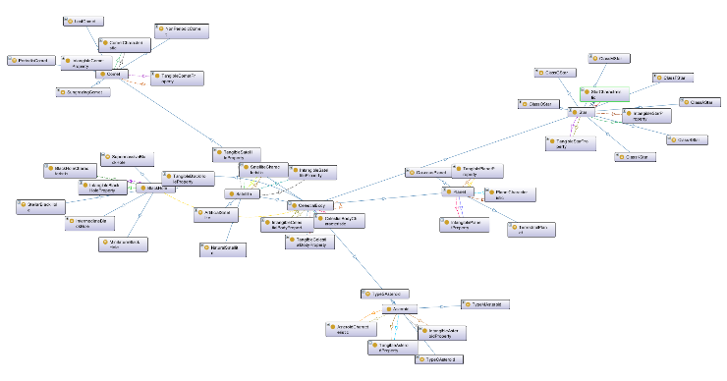

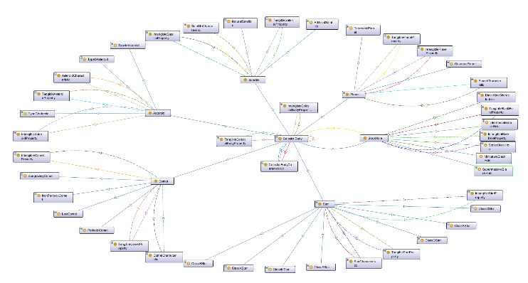

1. Spring and Radial Visualizations of Ontology using *OntoGraf*

Fig. 3 indicates the main celestial body classification taxonomy, and the three-tier relational structure to capture their various properties and characteristics (as described in Section II).

The concluding phase of the adopted ontology development methodology encompasses the evaluation of the ontology. We measure of completeness and adequacy of our ontology by its ability to answer the competency questions.

### Competency Questions

Our Celestial Body Classification Ontology is capable of answering all 57 competency questions identified at the beginning of its development, however a chosen subset of 5 of these competency questions are examined in this report.

As indicated by the intended user groups in Section I, these questions can be viewed as being posed by an interstellar visitor entering our Solar system for the first time who wants to gather information about its celestial bodies.

Many of the competency questions were surrounding various properties or characteristics of Earth. This is naturally due to Earth being the most well-documented celestial body. However, as indicated earlier, this ontology can capture the information surrounding any celestial body, not limited to those just within our Solar System. A snapshot of Earth properties in Protégé has been provided in Fig. 4 below.

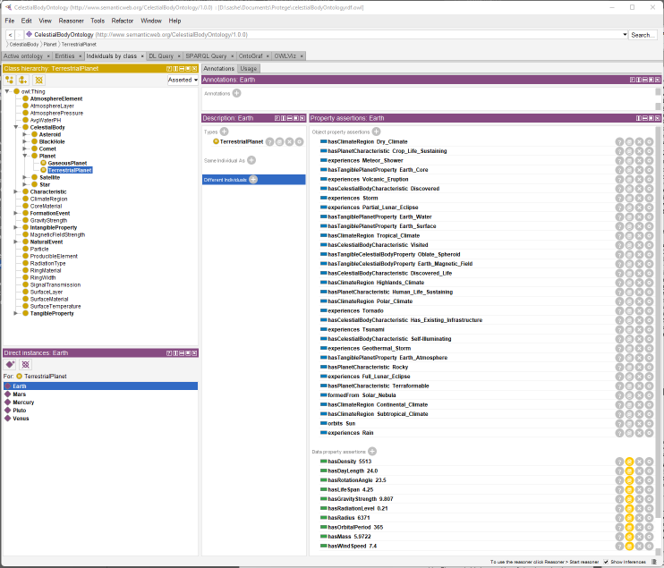

1. Snapshot of fully-developed Earth individual in Protégé

As we can see there is plenty of information captured about Earth, and we expect this level of detail to carry forward to any other celestial body individual.

A chosen subset of 5 competency questions were selected to present in this report. The SPARQL query and its results are presented in Fig. 5-9 to answer these respective 5 competency questions.

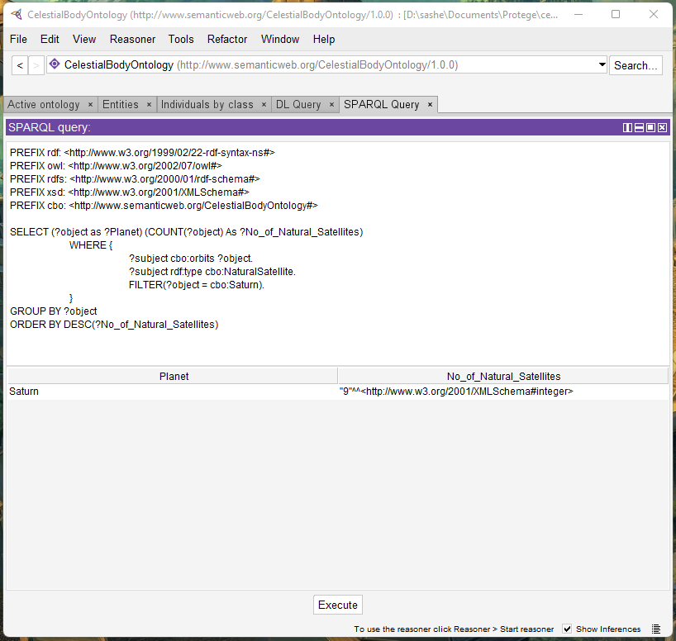

1. SPARQL query for “How many natural satellites does Saturn have?”

*Fig. 5 - How many natural satellites does Saturn have?* A key question one might ask when considering a celestial cluster is how many natural satellites a planet might have. As Saturn has numerous natural satellites, it is most suitable for this question. As seen in Fig. 5, the ontology is able to answer this via the following query structure. We first create our main query pattern which is centered around the ‘*orbits*’ property. From this we select only those subjects which are artificial satellites orbiting a celestial body. We further refine this by filtering those artificial satellites which orbit Saturn. Finally, we count the number of rows and return this as the query output. As we can see, the ontology indicates that Saturn has 9 natural satellites.

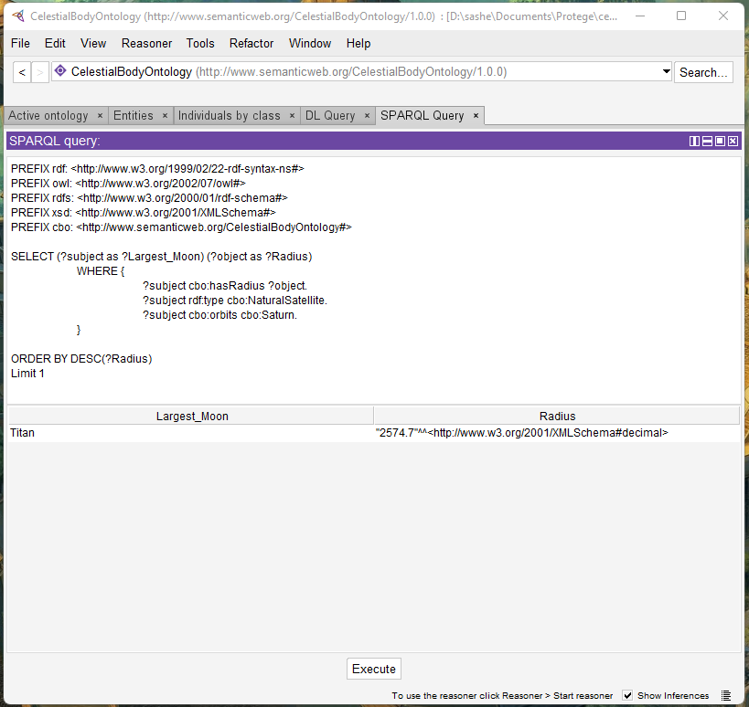

1. SPARQL query for “What is the largest satellite that orbits Saturn, and what is its radius?”

*Fig. 6 - What is the largest natural satellite that orbits Saturn, and what is its radius?* As Saturn has many moons, in fact 9 as indicated by our previous query (see Fig. 5), one might be interested in finding out which of its moons is largest. We quantify how large a natural satellite is by its radius. Hence, the ‘*hasRadius*’ property is main pattern element for which we match against. We then match the subject and object to Natural satellites that orbit Saturn. From this main query we get a list of the natural satellites of Saturn, and their respective radius. Finally, we sort these natural satellites by their radius in descending order, where only the top 1 result is returned. The output of the query can be seen as Titan being the largest natural satellite of Saturn with a radius of 2574.7 km.

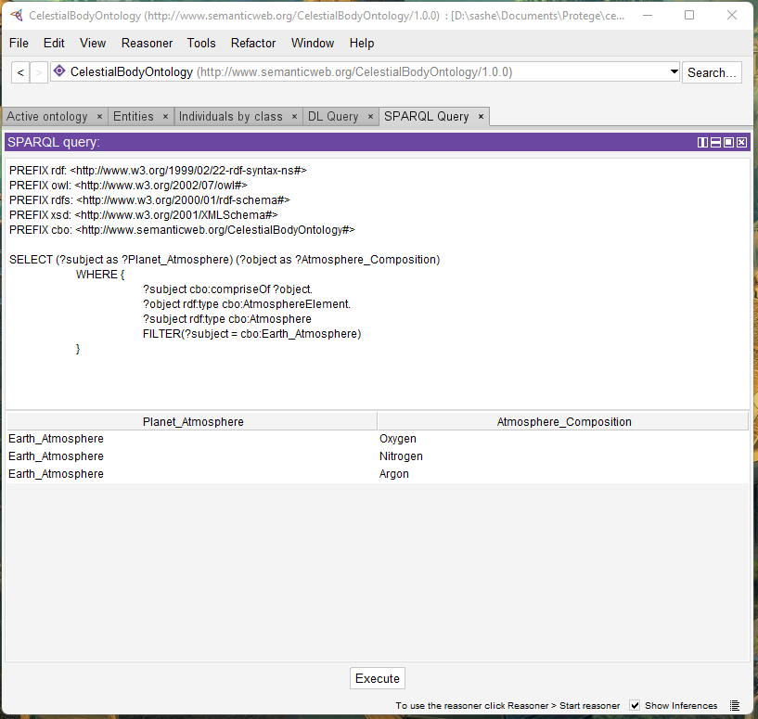

1. SPARQL query for“What is the main atmospheric compostion of Earth?”

*Fig. 7 - What is the main atmospheric composition of Earth?* Finding out the atmospheric composition of a planet can be useful for determining if humans could breathe, if the environment is toxic, if the atmosphere is rich with plant-life sustaining elements etc. Our ontology is able to determine this will the following query structure. We first create the main pattern which is matched against the ‘*compriseOf*’ property. From this we further refine the query by getting those atmosphere elements comprising any atmosphere currently captured in the ontology. Finally, the results are filtered to get those elements comprising Earth’s atmosphere. As we can see, the ontology indicates that earth’s atmosphere comprises of Oxygen, Nitrogen, and Argon.

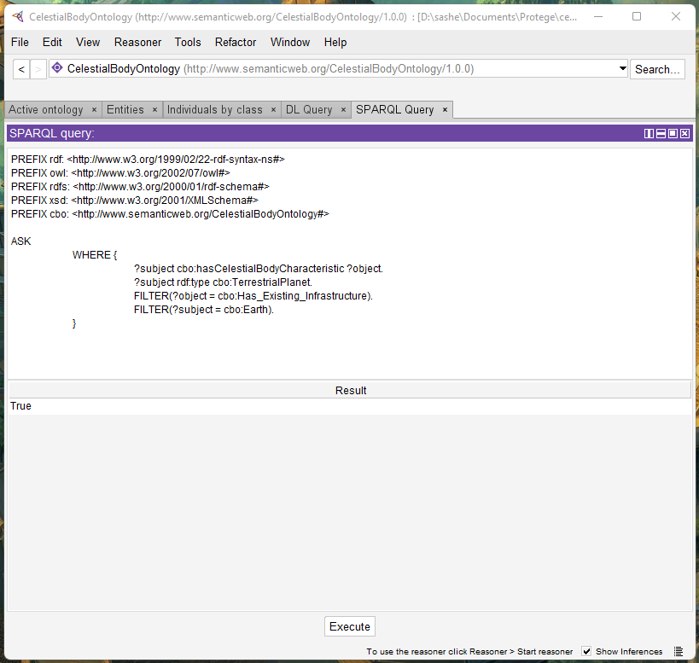

1. SPARQL query for“Does Earth have any existing infrastucture in place?”

*Fig. 8 - Does Earth have any existing infrastructure in place?* Whilst this might be a seemingly obvious question to us, this question demonstrates the ontologies widespread use, in that it can be used by anyone even those not from this solar system to gain information about a celestial cluster. The query is structured as follows. Firstly, we format the query with the ‘*ASK*’ element to get a True or False output. From this we create the main pattern matching elements involved in the ‘*hasCelestialBodyCharacteristic*’ property. We then refine the results by examining only those terrestrial planets having existing infrastructure. Finally, we filter those terrestrial planets down to the specific planet: Earth. As we can see the ontology outputs True. Interpreting this we can see that Earth has the celestial body characteristic of having existing infrastructure in place.

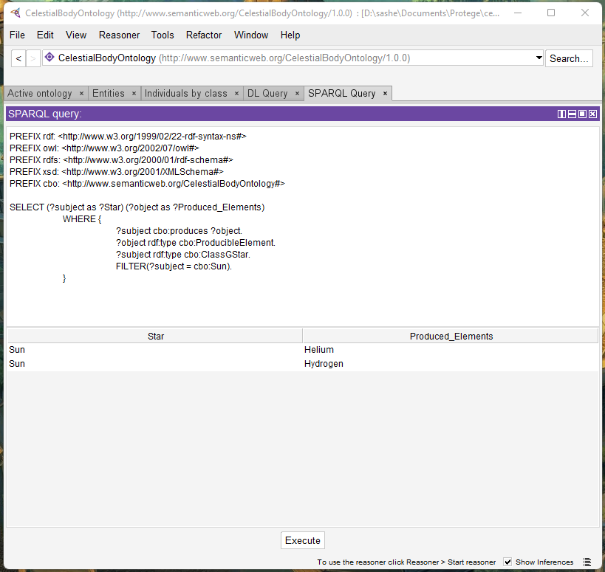

1. SPARQL query for“What elements does the Sun produce?”

*Fig. 9 - What elements does the Sun produce?* Stars are the furnaces of the universe, producing many of the elements we find today. A local example of this the only star in the solar system - the Sun. The presented ontology is able to answer this with the following query structure. Firstly, we create the main query pattern with the specified produces property. These results are then refined by specifying only those elements produced by ‘*GlassGStars*’. Finally, we filter the Sun from the ‘*ClassGStars*’. As we can see, the ontology indicates that the Sun produces Hydrogen and Helium.

It is evident from Fig. 5-9 that the ontology is fully capable of expressing various aspects around the celestial bodies, thus it can fully service the questions posed within its domain.

The full list of 57 competency questions along with their respective SPARQL queries and outputs are presented in Appendix A. Additionally, these figures are provided in a separate folder titled: “Figures” within the submission for improved clarity.

### Consistency Checks

Furthermore, to check the consistency of our ontology we ran the HermiT reasoner in Protégé. The configuration of this reasoner is provided in Appendix B Fig. B1. Additionally, the reasoner can provide inferences based on the existing logic modelling. These inferences can be categorized as:

* class inferences,
* object property inferences,
* data property inferences, and
* individual inferences.

Firstly, the reasoner detected no inconsistencies with the ontology. Should any inconsistencies be detected, Protégé would provide an alert that the reasoner cannot create inferences. For reference, an example of an inconsistent ontology would result in the alert presented in Appendix B Fig. B2. Thankfully, this was not the case with our ontology, as the reasoner indicated our ontology resembled consistent characteristics, and was successfully able to make inferences.

The outcomes of the various inference types are presented in Fig. 10-13 below. Once again, for improved clarity, these figures are provided in a separate folder titled “Figures” within the submission.

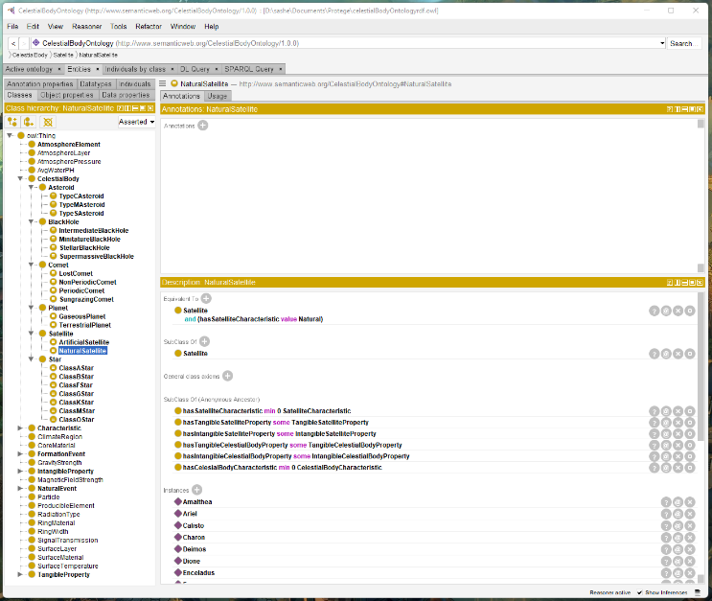

Fig. 10a. Asserted class hierarchy

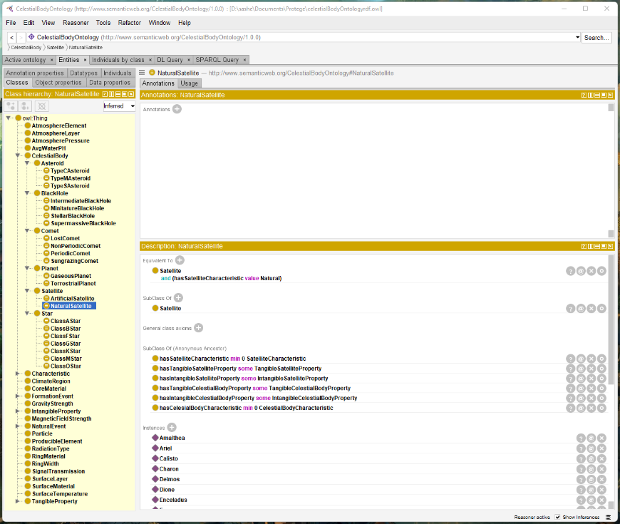

Fig. 10b. Inferred class hierarchy

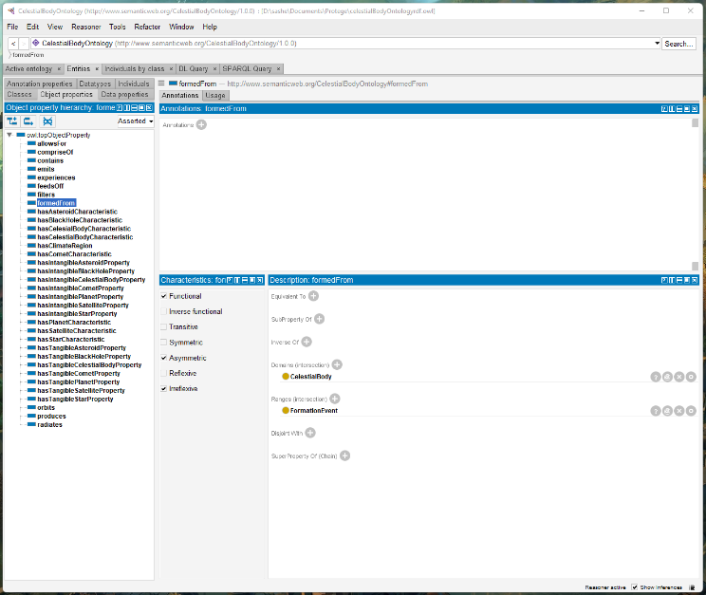

Fig. 11a. Asserted object properties

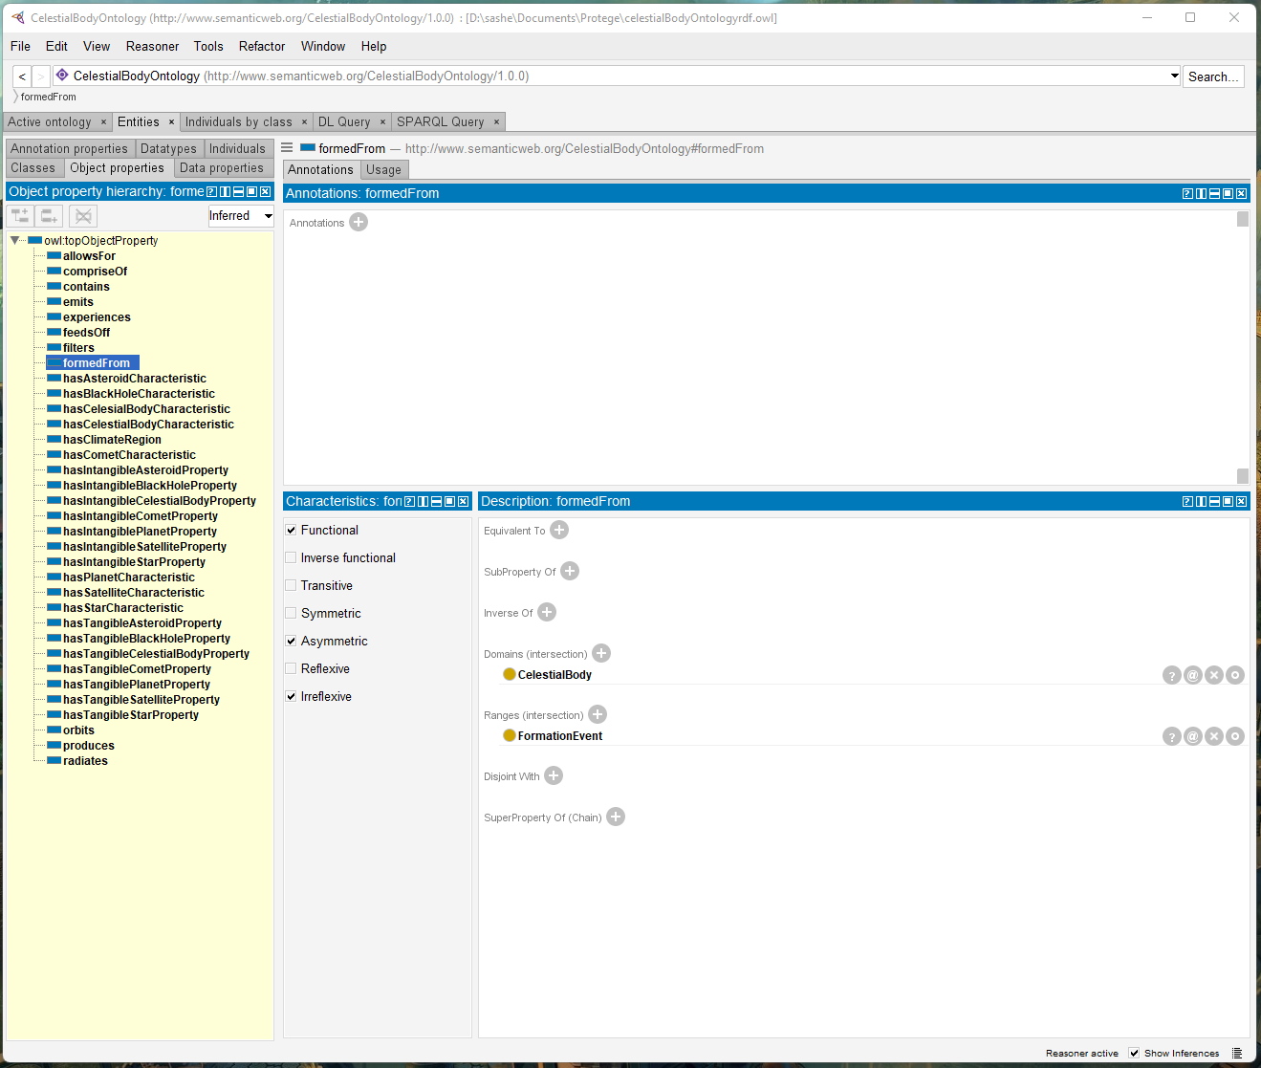

Fig. 11b. Inferred object properties

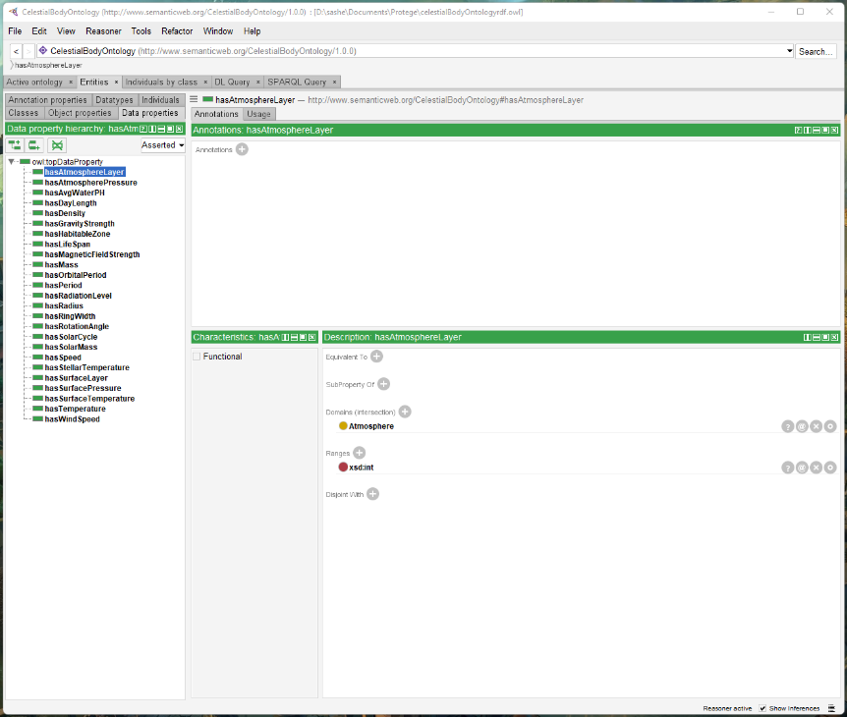

Fig. 12a. Asserted data properties

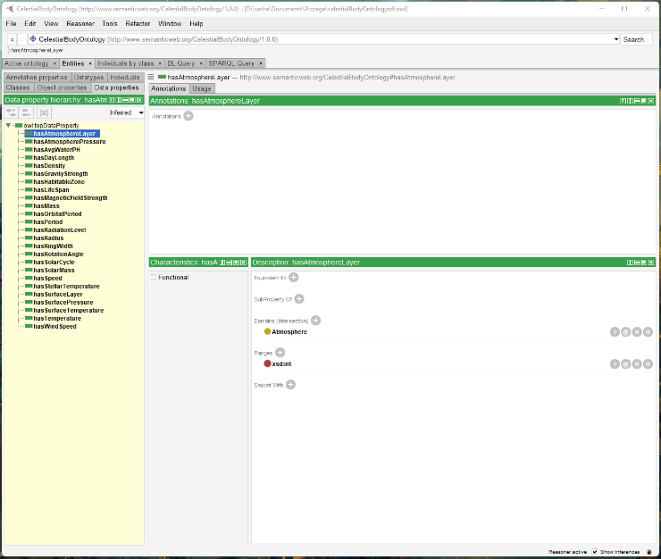

Fig. 12b. Inferred data properties

In examining the various inferences represented in Fig 10.a – 12b, we can see that the presented ontology resembled strong consistency as no inferences were made regarding the class hierarchies, object or data properties.

This is because the structuring of the main celestial body taxonomy was carefully chosen such that the classes would be atomic. That is, under a particular celestial body taxonomy, the chosen classification scheme was distinct and disjoint such that there would be no ambiguity to a given individual’s membership. This is further owning to the three-tier relational structure described in Section II.

However, as indicated by Fig 13.a and Fig 13.b below, the reasoner made an inference to consider ‘*Alpha_Centauri_B*’ as a Class G Star rather than a Class K Star. In examining this further we can detect that this is due to conflicting information in stellar classification. More specifically, various sources [35], [38] indicate that Alpha Centauri B is a Class K star. Class K stars have a temperature of ‘3500K-5000K’ [37]. However, Alpha Centauri B is known for fluctuating temperatures and is specified in the ontology with a temperature of 5260K [37]. Therefore, the inference would be correct in classifying it as a Class G Star.

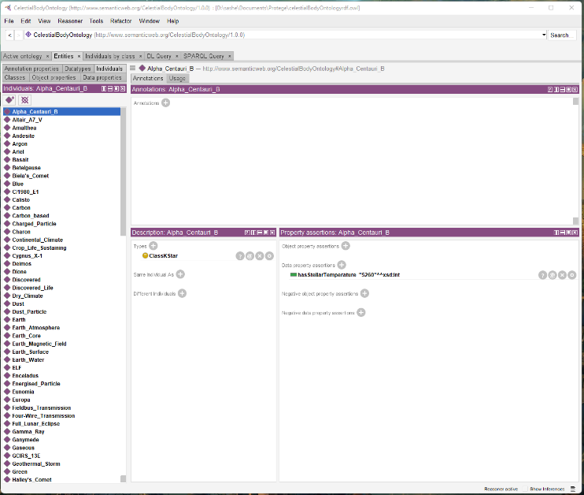

Fig. 13a. Asserted instances

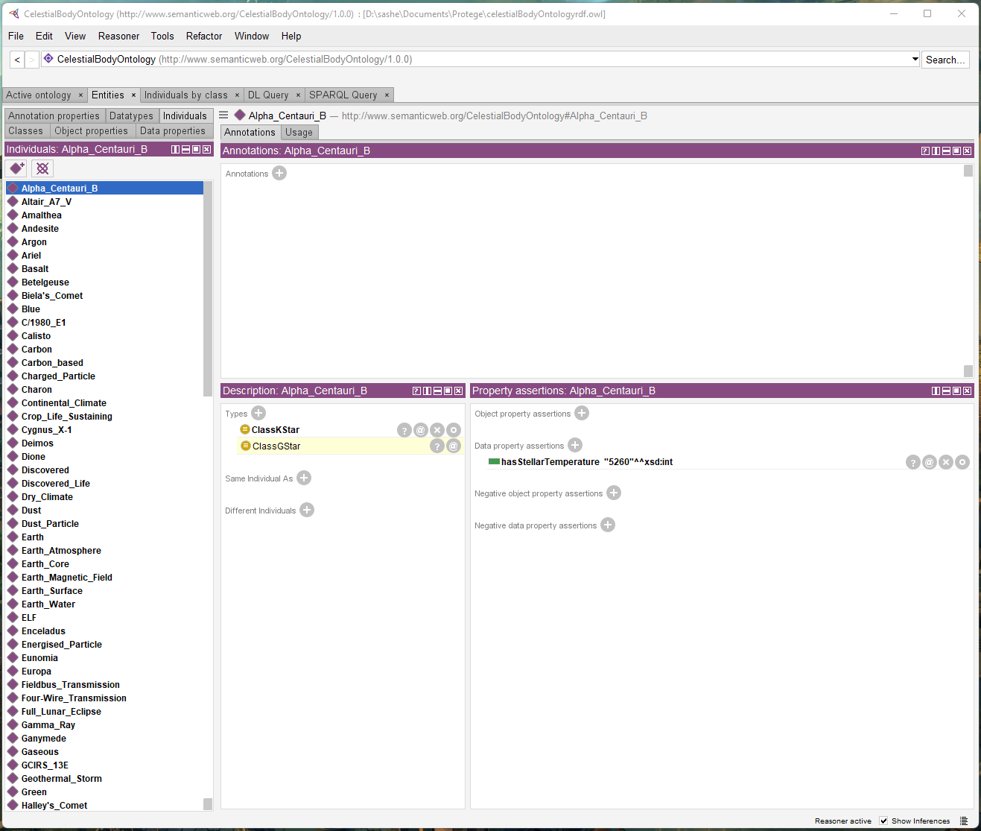

Fig. 13b. Inferred instances

If anything, this demonstrates the expressive powers of the ontology in that it is able to detect these fluctuations, and this inference was ultimately made due to a conflicting human views, and not the structure of the ontology itself.

From this empirical analysis of the presented ontology, we can see that it is capable of answering all of the competency questions raised at the beginning of this endeavor, whilst exhibiting high levels of consistency.

# Conclusion

The ontology presented in this paper hopes to contribute to the vast initiative of knowledge modelling, particularly in the space domain. It has been built using appropriate methodologies and frequent consultation regarding its efficacy. The result is a knowledge model that is capable of answering all raised competency questions and exhibits strong design principles as evident via its empirically high consistency. This ontology could be fruitfully deployed in various scenarios such as space research hypothesis testing, space educational tools, and even future spacecraft A.I navigational systems. Future research could look into expanding the three-tier relational structure to adhere to more artificial concepts such as dark matter, or integrating this ontology with domain-specific ontologies centered around a particular celestial body.

##### Acknowledgment

We would like to acknowledge our lecturer Dr. Jean Vincent Fonou Dombeu for his consistent guidance throughout the development of this ontology.

# References

[1] ‘Celestial Bodies - Meaning, Classification & Heavenly Bodies Names’, *BYJUS*. https://byjus.com/physics/celestial-bodies/ (accessed Mar. 23, 2022).

[2] ‘Celestial Bodies’, *VEDANTU*. https://www.vedantu.com/physics/celestial-bodies, (accessed Mar. 23, 2022).

[3] ‘Introduction of Celestial Bodies in Physics | AESL’. https://www.aakash.ac.in/important-concepts/physics/celestial-bodies (accessed Mar. 30, 2022).

[4] D. M. Bang Carol D. Lee,Megan, ‘Point of View Affects How Science Is Done’, *Scientific American*. https://www.scientificamerican.com/article/point-of-view-affects-how-science-is-done/ (accessed Mar. 30, 2022).

[5] R. J. Rovetto, ‘The Space Object Ontology’, *2016*, vol. 1, 2016.

[6] M. Wei-Haas, ‘Black Holes, Explained’, *Science*, Sep. 21, 2018. https://www.nationalgeographic.com/science/article/black-holes (accessed Mar. 30, 2022).

[7] A. P. Cox, C. K. Nebelecky, R. Rudnicki, W. A. Tagliaferri, J. L. Crassidis, and B. Smith, ‘The Space Object Ontology’, p. 8.

[8] NASA, ‘In Depth | Asteroids’, *NASA Solar System Exploration*. https://solarsystem.nasa.gov/asteroids-comets-and-meteors/asteroids/in-depth (accessed Mar. 23, 2022).

[9] A. Campbell, ‘What is a satellite?’, *NASA*, May 06, 2015. http://www.nasa.gov/directorates/heo/scan/communications/outreach/funfacts/txt_satellite.html (accessed Mar. 30, 2022).

[10] ‘Overview | Planet Types’, *Exoplanet Exploration: Planets Beyond our Solar System*. https://exoplanets.nasa.gov/what-is-an-exoplanet/planet-types/overview (accessed Apr. 16, 2022).

[11] M. J. Aschwanden, ‘CHAPTER 4 - The Sun’, in *Encyclopedia of the Solar System (Second Edition)*, L.-A. McFadden, P. R. Weissman, and T. V. Johnson, Eds. San Diego: Academic Press, 2007, pp. 71–98. doi: 10.1016/B978-012088589-3/50008-6.

[12] K. Bobst, ‘What Are the Different Types of Comets?’, *Treehugger*. https://www.treehugger.com/what-are-the-different-types-of-comets-4863817 (accessed Apr. 16, 2022).

[13] G. Paquette, O. Marino, and R. Bejaoui, ‘A new competency ontology for learning environments personalization’, *Smart Learning Environments*, vol. 8, no. 1, p. 16, Aug. 2021, doi: 10.1186/s40561-021-00160-z.

[14] ‘tangible’. https://dictionary.cambridge.org/dictionary/english/tangible (accessed Mar. 30, 2022).

[15] ‘intangible’. https://dictionary.cambridge.org/dictionary/english/intangible (accessed Mar. 30, 2022).

[16] ‘characteristic’. https://dictionary.cambridge.org/dictionary/english/characteristic (accessed Mar. 30, 2022).

[17] NASA, ‘Asteroid Fact Sheet’. https://nssdc.gsfc.nasa.gov/planetary/factsheet/asteroidfact.html (accessed Apr. 15, 2022).

[18] NASA, ‘Comet Fact Sheet’. https://nssdc.gsfc.nasa.gov/planetary/factsheet/cometfact.html (accessed Apr. 15, 2022).

[19] ‘Planetary Fact Sheet’. https://nssdc.gsfc.nasa.gov/planetary/factsheet/ (accessed Apr. 16, 2022).

[20] H. Karttunen, P. Kröger, H. Oja, M. Poutanen, and K. J. Donner, Eds., ‘Cosmology’, in *Fundamental Astronomy*, Berlin, Heidelberg: Springer, 2007, pp. 393–414. doi: 10.1007/978-3-540-34144-4_19.

[21] H. Karttunen, P. Kröger, H. Oja, M. Poutanen, and K. J. Donner, Eds., ‘Star Clusters and Associations’, in *Fundamental Astronomy*, Berlin, Heidelberg: Springer, 2007, pp. 339–345. doi: 10.1007/978-3-540-34144-4_16.

[22] H. Karttunen, P. Kröger, H. Oja, M. Poutanen, and K. J. Donner, Eds., ‘The Milky Way’, in *Fundamental Astronomy*, Berlin, Heidelberg: Springer, 2007, pp. 347–366. doi: 10.1007/978-3-540-34144-4_17.

[23] H. Karttunen, P. Kröger, H. Oja, M. Poutanen, and K. J. Donner, Eds., ‘The Solar System’, in *Fundamental Astronomy*, Berlin, Heidelberg: Springer, 2007, pp. 131–205. doi: 10.1007/978-3-540-34144-4_7.

[24] H. Karttunen, P. Kröger, H. Oja, M. Poutanen, and K. J. Donner, Eds., ‘The Sun’, in *Fundamental Astronomy*, Berlin, Heidelberg: Springer, 2007, pp. 263–277. doi: 10.1007/978-3-540-34144-4_12.

[25] R. Rovetto, ‘Ontology-based Knowledge Management for Space Data’, Sep. 2017.

[26] P. Fox *et al.*, ‘Ontology-supported scientific data frameworks: The Virtual Solar-Terrestrial Observatory experience’, *Computers & Geosciences*, vol. 35, no. 4, pp. 724–738, Apr. 2009, doi: 10.1016/j.cageo.2007.12.019.

[27] S. W, W. J, and L. F Y, ‘Simulation Dataset on Planet Juncture Index and Heliocentric Longitude of Planetary System Barycentre’, *Journal of Global Change Data & Discovery*, vol. 2, no. 4, pp. 382–388, 2018, doi: 10.3974/geodp.2018.04.03.

[28] D. A. O’Neil and R. J. Rovetto, ‘An Ontology-Based Virtual Orrery’, M–1516, Jan. 2021. Accessed: Apr. 15, 2022. [Online]. Available: https://ntrs.nasa.gov/citations/20210000030

[29] S. Earley, ‘The Role of Ontology and Information Architecture in AI’. https://www.earley.com/insights/role-ontology-and-information-architecture-ai (accessed Mar. 30, 2022).

[30] R. Garner, ‘What Are Black Holes?’, *NASA*, Nov. 15, 2017. http://www.nasa.gov/vision/universe/starsgalaxies/black_hole_description.html (accessed Mar. 23, 2022).

[31] N. G. Society, ‘core’, *National Geographic Society*, Aug. 17, 2015. http://www.nationalgeographic.org/encyclopedia/core/ (accessed Mar. 30, 2022).

[32] T. Talbert, ‘What’s the Difference Between Asteroids, Comets and Meteors?’, *NASA*, Dec. 13, 2021. http://www.nasa.gov/feature/episode-16-we-asked-a-nasa-scientist-what-s-the-difference-between-asteroids-comets-and (accessed Mar. 23, 2022).

[33] ‘Are black holes a celestial body?’, *Quora*. https://www.quora.com/Are-black-holes-a-celestial-body (accessed Mar. 30, 2022).

[34] ‘black hole | Definition, Formation, Types, Pictures, & Facts | Britannica’. https://www.britannica.com/science/black-hole (accessed Apr. 15, 2022).

[35] ‘Exploring the stars: Six star types you should know about’. https://warwick.ac.uk/newsandevents/knowledgecentre/science/physics-astrophysics/star_types/ (accessed Mar. 23, 2022).

[36] ‘list of moons | Britannica’. https://www.britannica.com/topic/list-of-moons-2033266 (accessed Mar. 30, 2022).

[37] ‘stellar classification | astronomy | Britannica’. https://www.britannica.com/science/stellar-classification (accessed Apr. 15, 2022).

[38] ‘Types Of Stars - A Comprehensive Guide • The Planets’, *The Planets*. https://theplanets.org/types-of-stars/ (accessed Mar. 23, 2022).

[39] ‘What Is a Black Hole?’ https://www.nationalgeographic.com/science/article/black-holes (accessed Mar. 23, 2022).

# Appendix A – Full Competency Questions

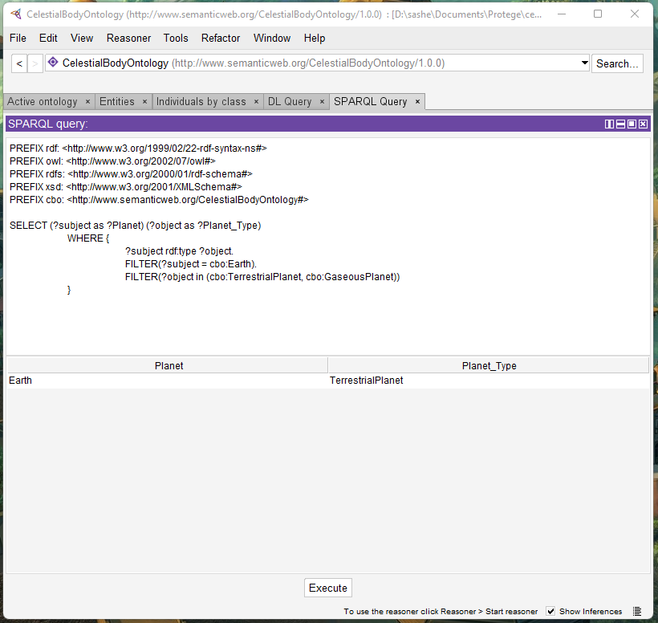

Fig. A1. What type of celestial body is the Earth?

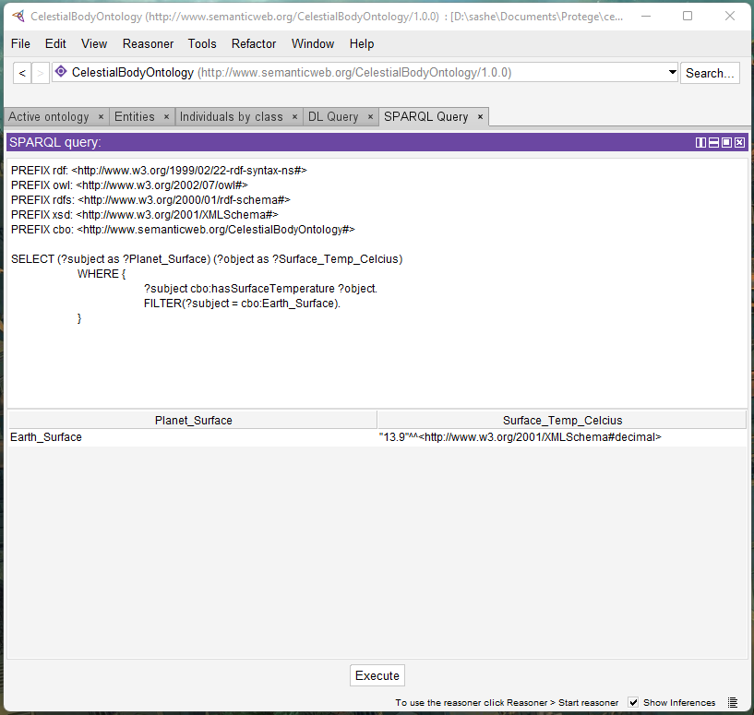

Fig. A2. What is the average surface temperature of the Earth?

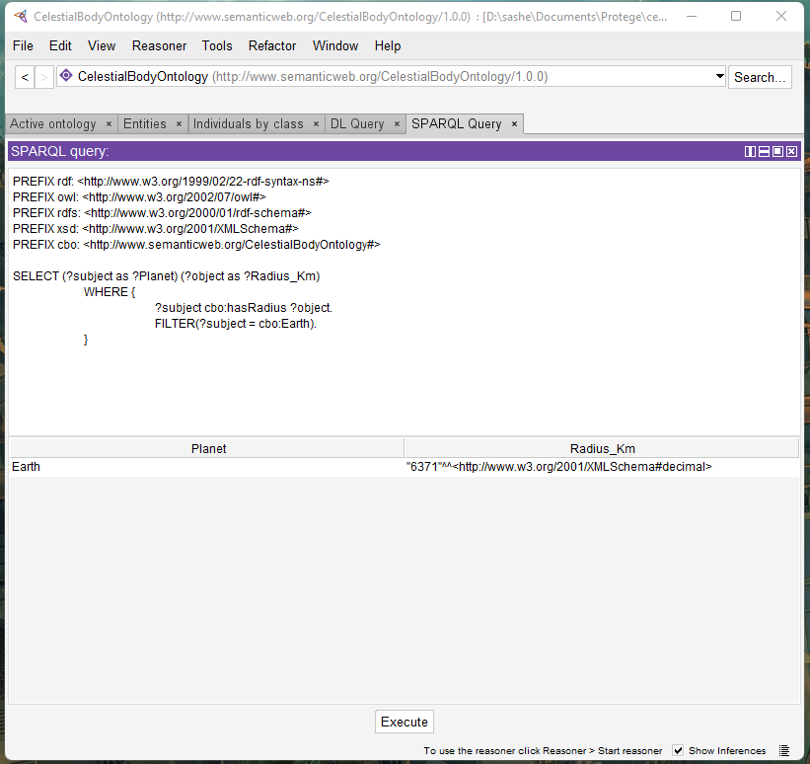

Fig. A3. What is the radius of the Earth?

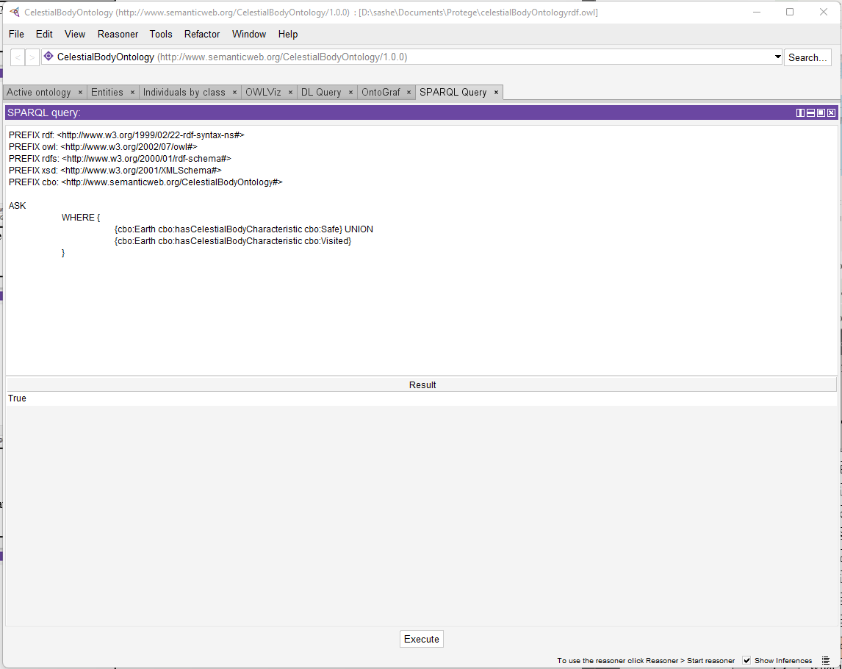Fig. A4. Is the Earth suitable for a landing operation?

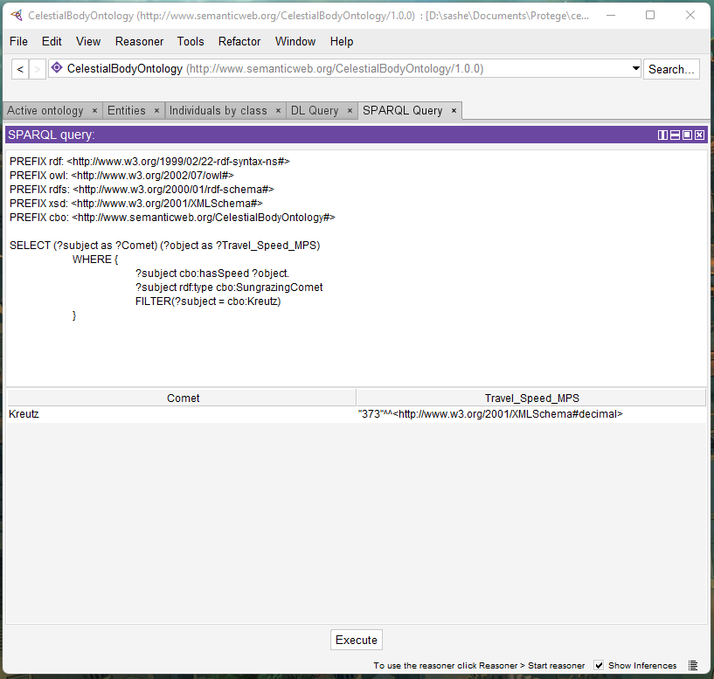

Fig. A5. What is the speed of Kreutz?

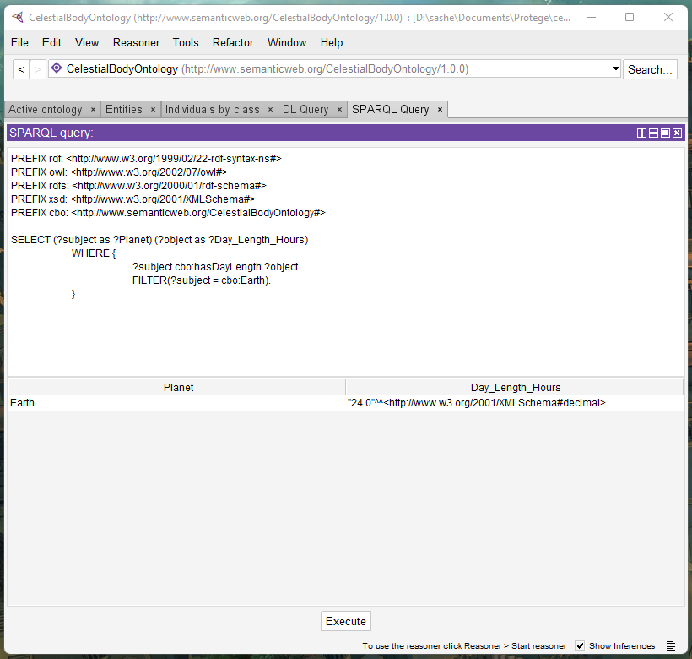

Fig. A6. How long is a day on Earth?

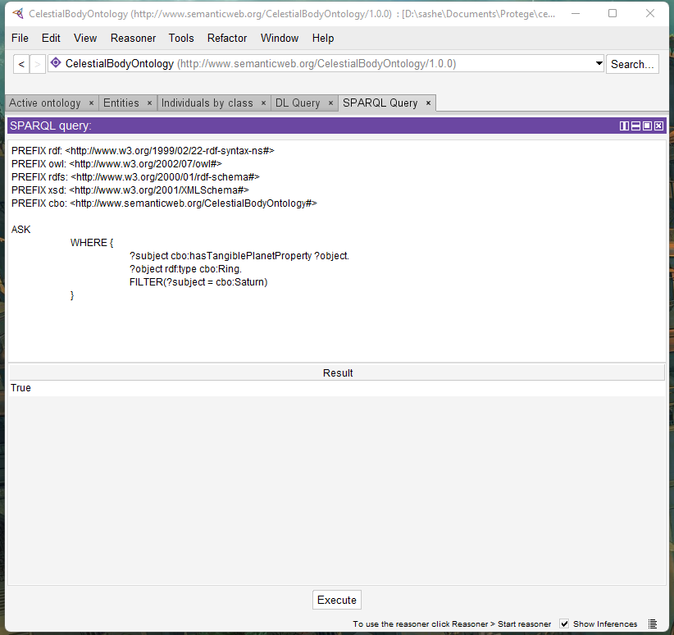

Fig. A7. Does Saturn have any rings?

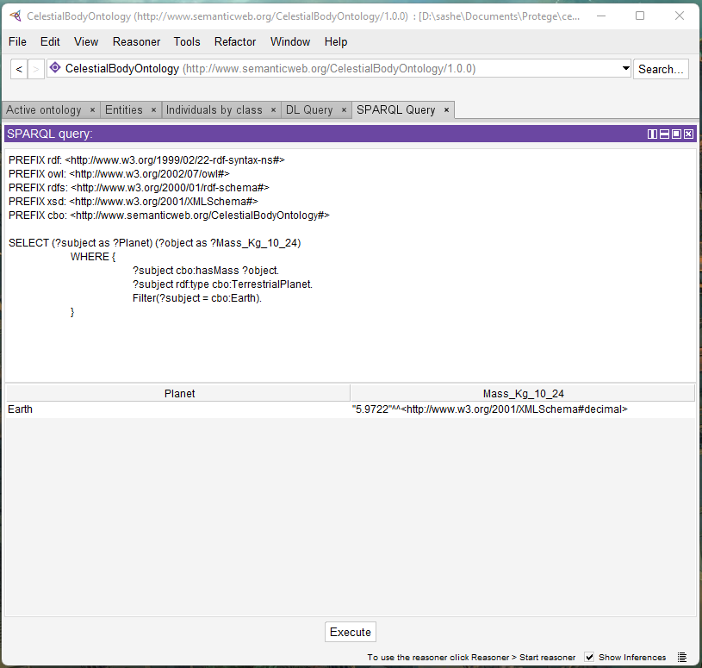

Fig. A8. How much mass is Earth comprised of?

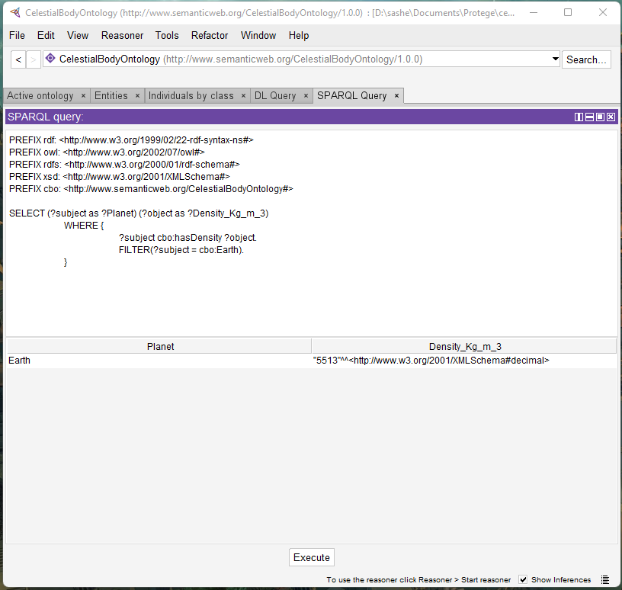

Fig. A9. What is the density of Earth?

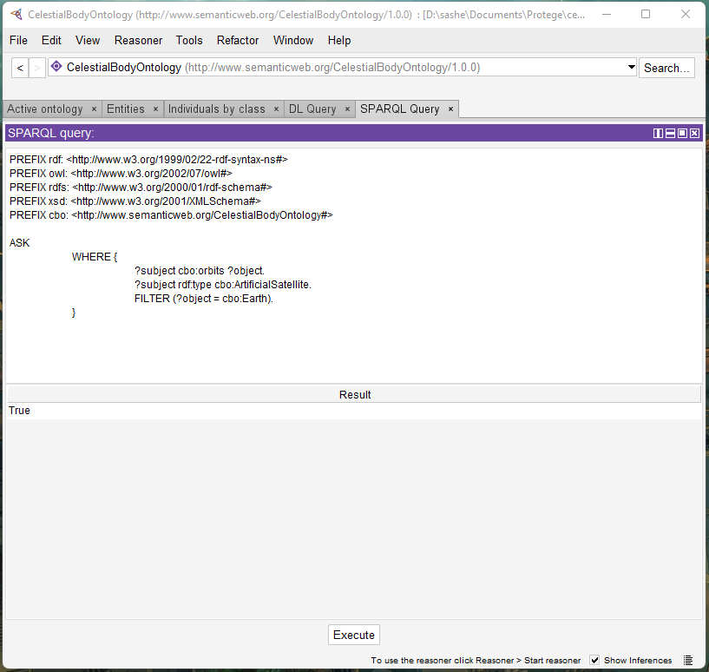

Fig. A10. Does Earth have body have any orbiting artificial satellites?

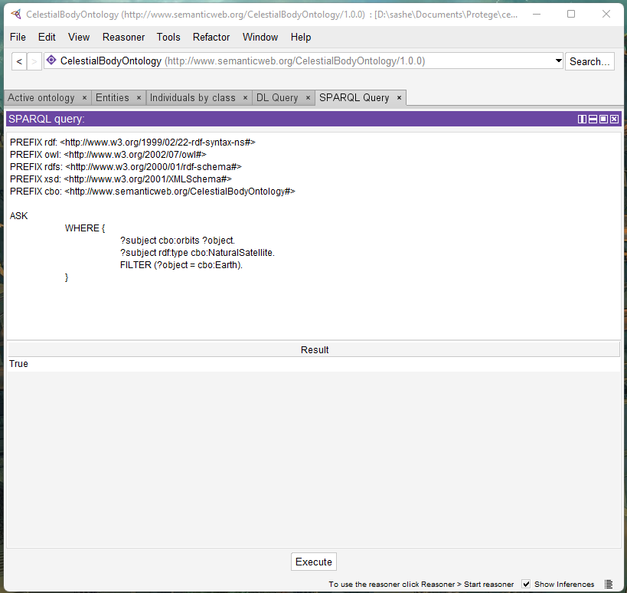

Fig. A11. Does Earth have any orbiting natural satellites?



Fig. A12. How many natural satellites does Saturn have?

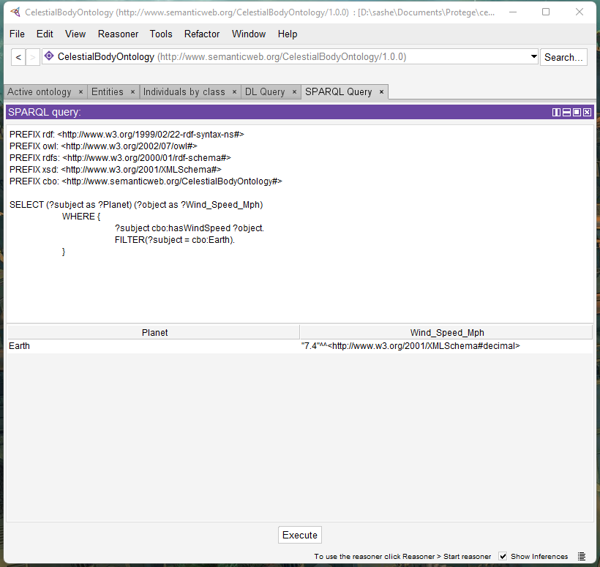

Fig. A13. What is the wind speed on Earth?

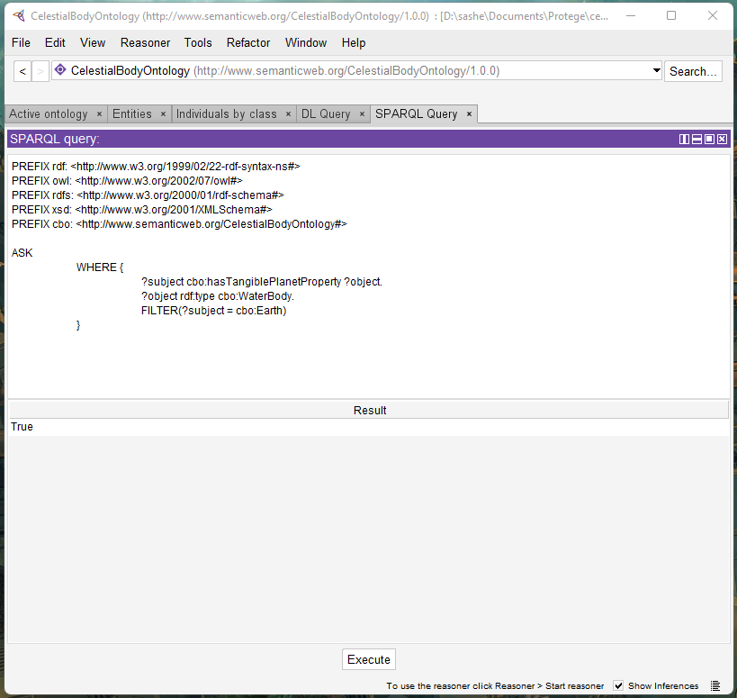

Fig. A14. Does Earth have any known bodies of water?

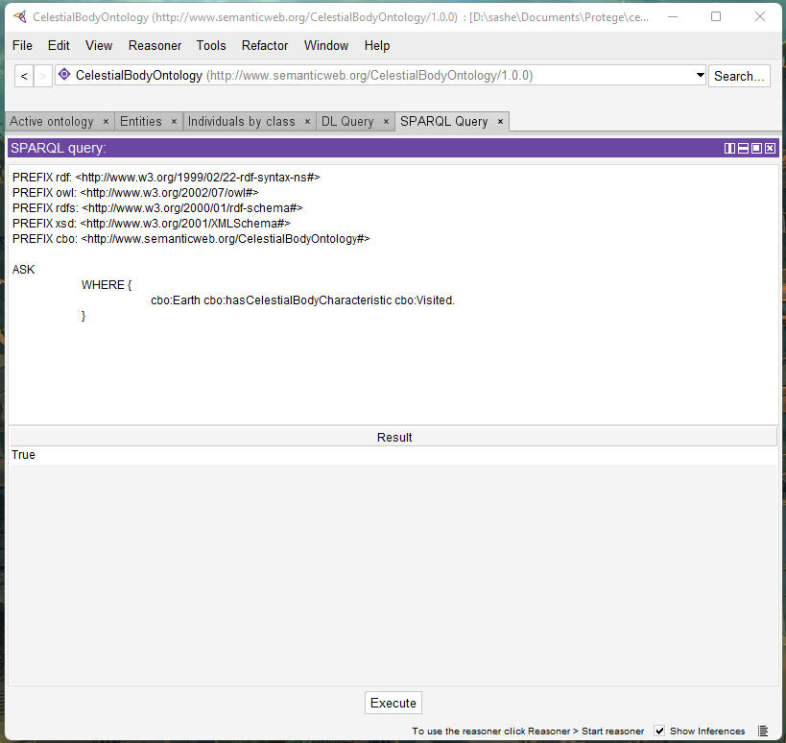

Fig. A15. Has Earth been visited before?

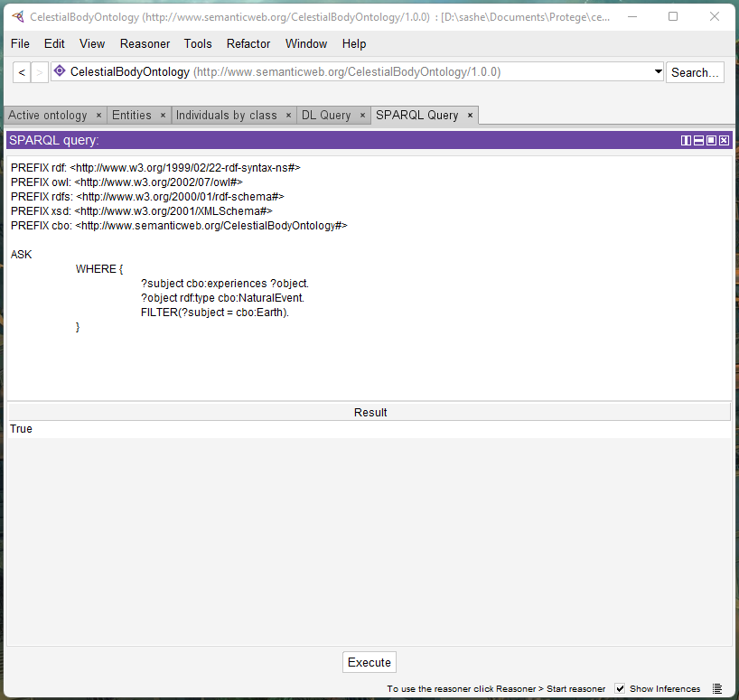

Fig. A16. Does Earth experience any natural events?



Fig. A17. Does Earth have any existing infrastructure in place?

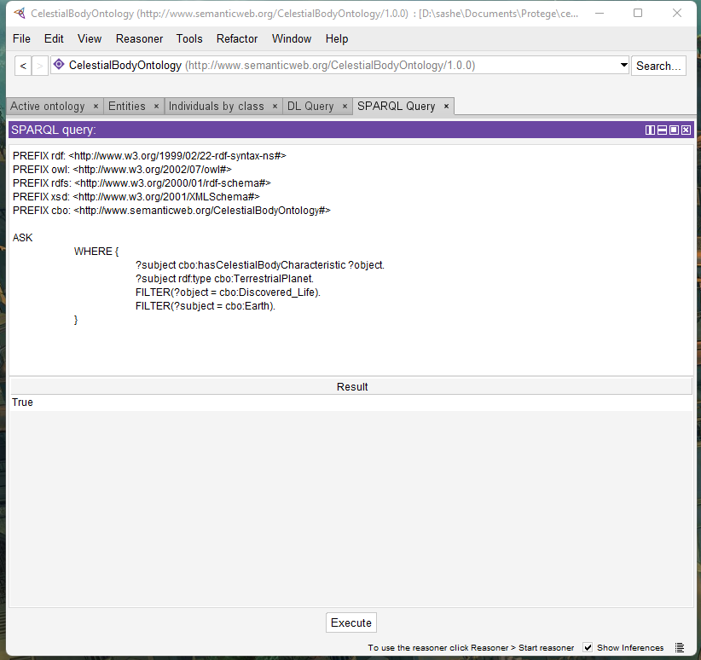

Fig. A18. Has life been discovered on Earth?



Fig. A19. What is the main atmospheric composition of Earth?

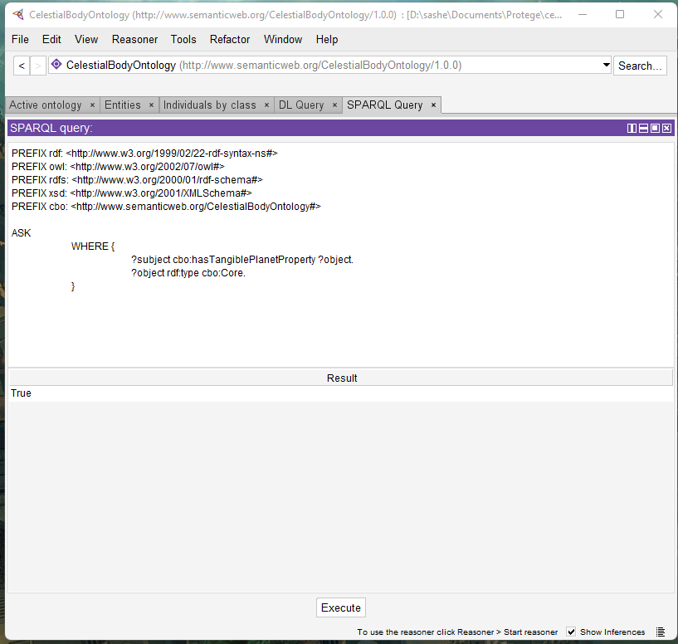

Fig. A20. Does Earth have a core?

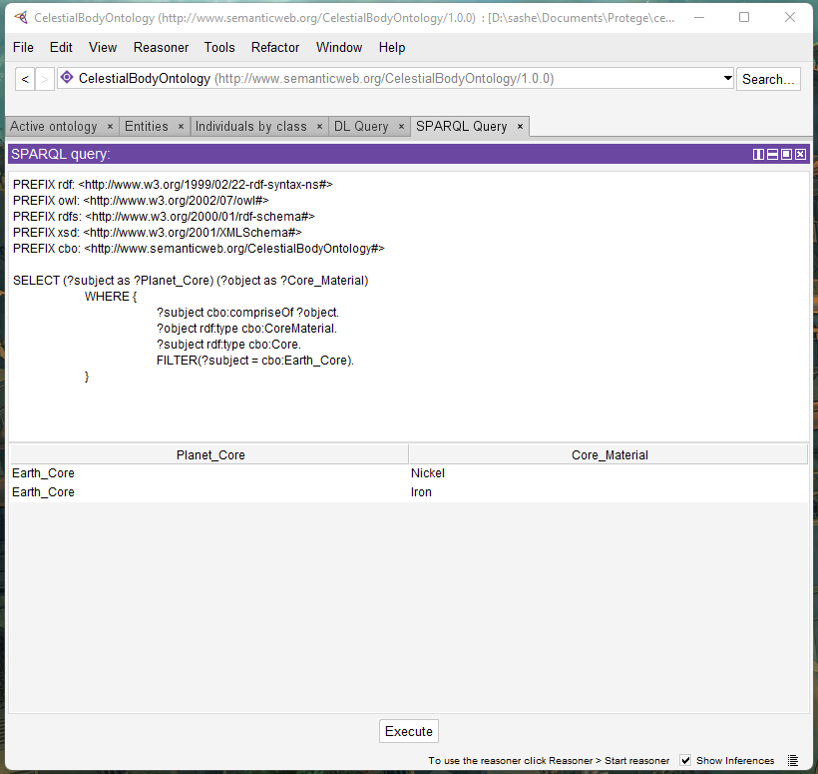

Fig. A21. What materials compose Earth’s core?

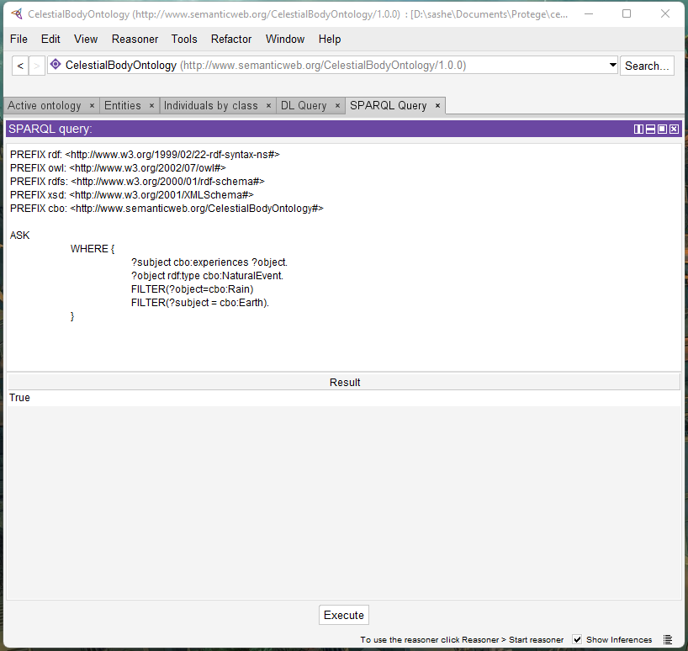

Fig. A22. Does it rain on Earth?

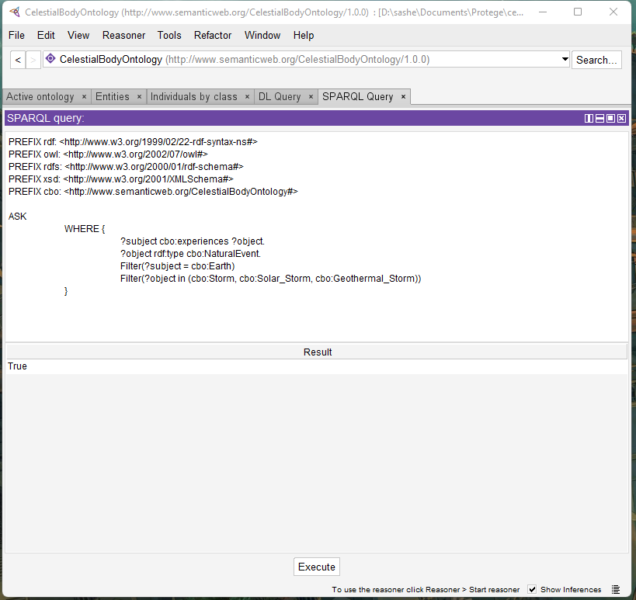

Fig. A23. Are storms a possibility on Earth?

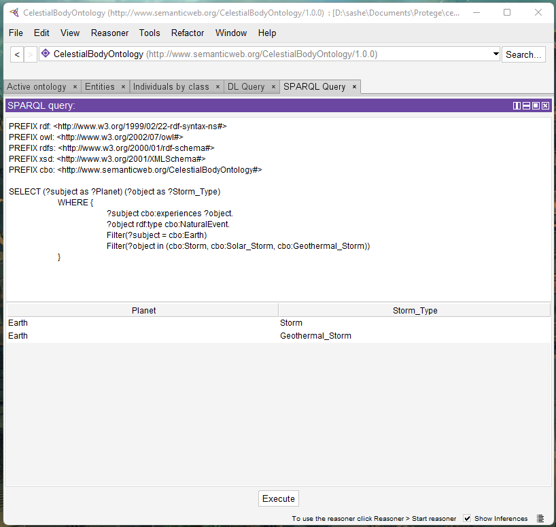

Fig. A24. What type of storms occur on Earth?

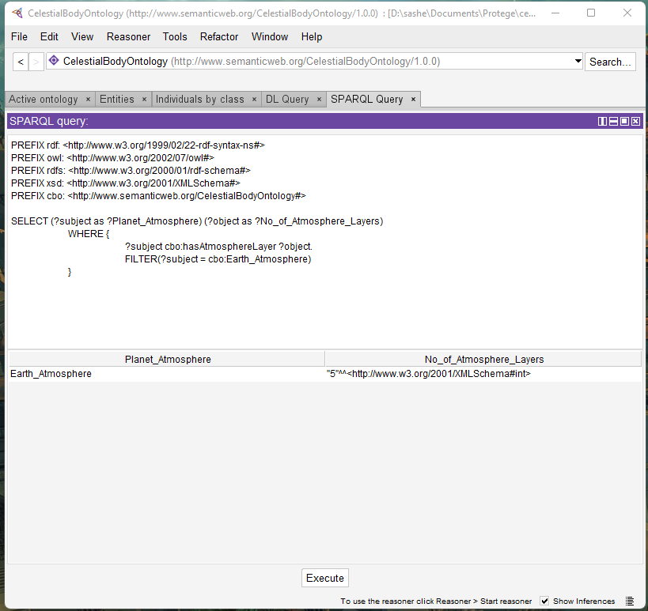

Fig. A25. How many atmospheric layers are present on Earth?

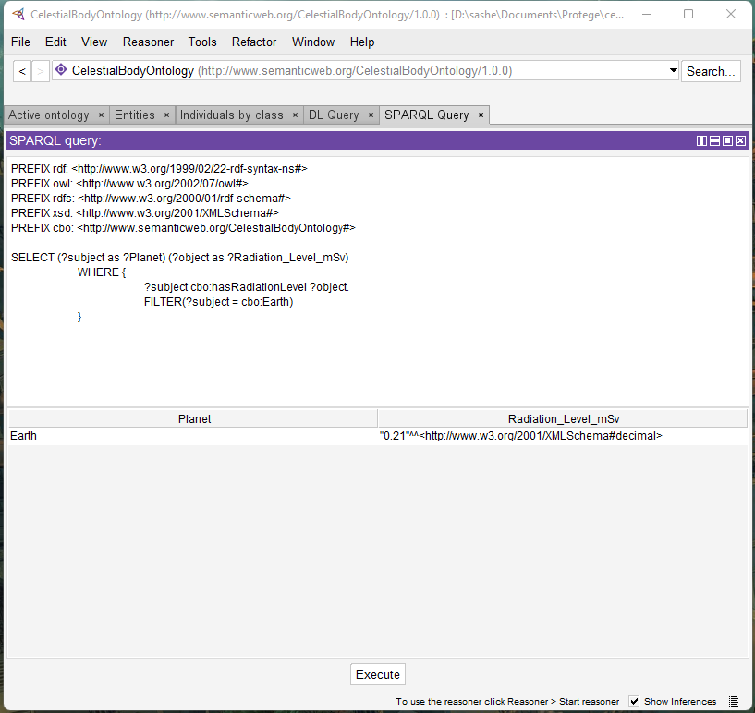

Fig. A26. What is the radiation level on Earth?

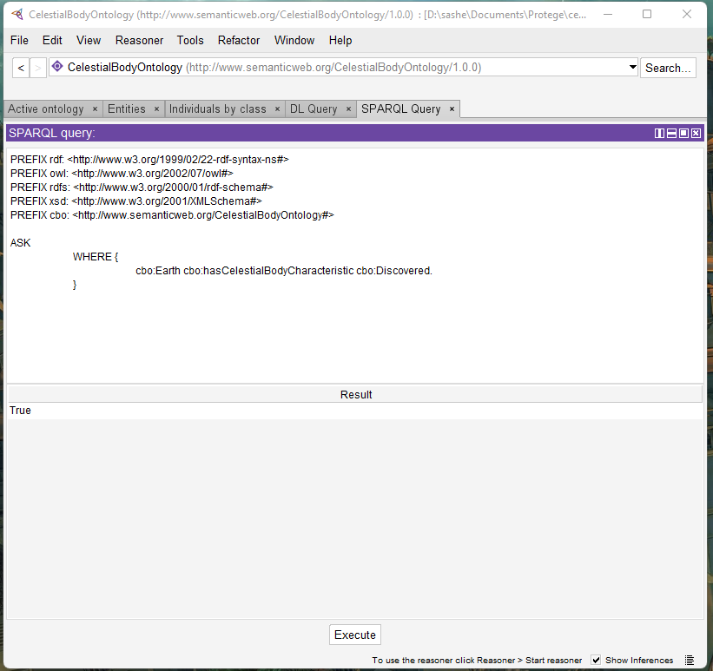

Fig. A27. Has Earth been discovered before?

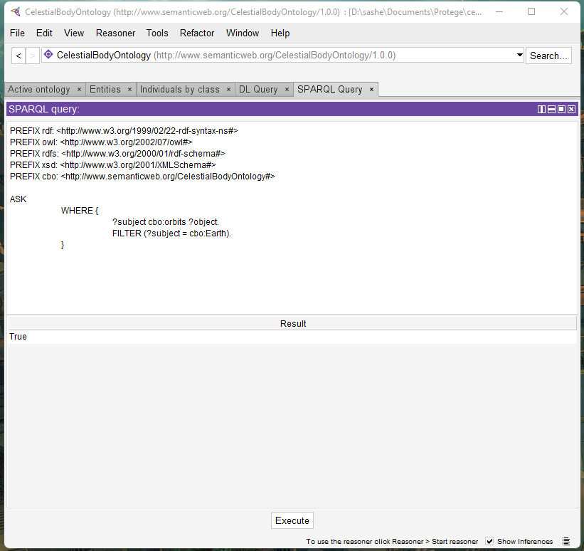

Fig. A28. Does Earth orbit anything?

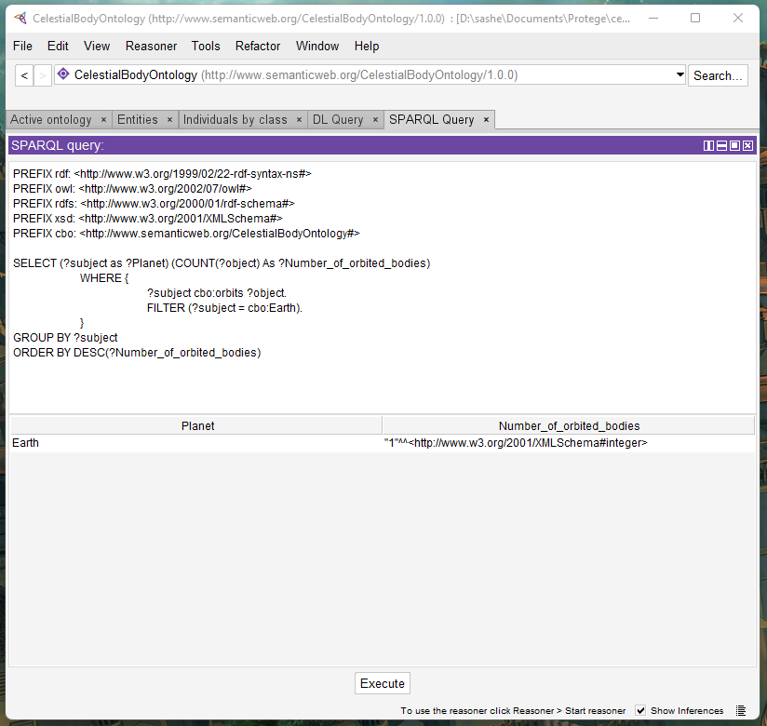

Fig. A29. How many other celestial bodies does Earth orbit?

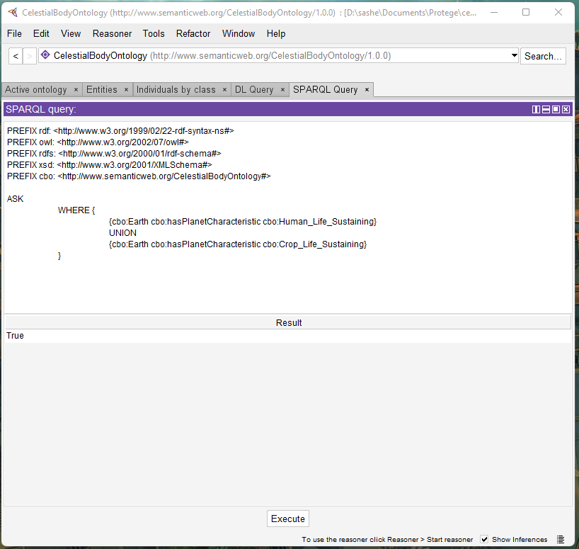

Fig. A30. Can Earth natively support crop or human life?

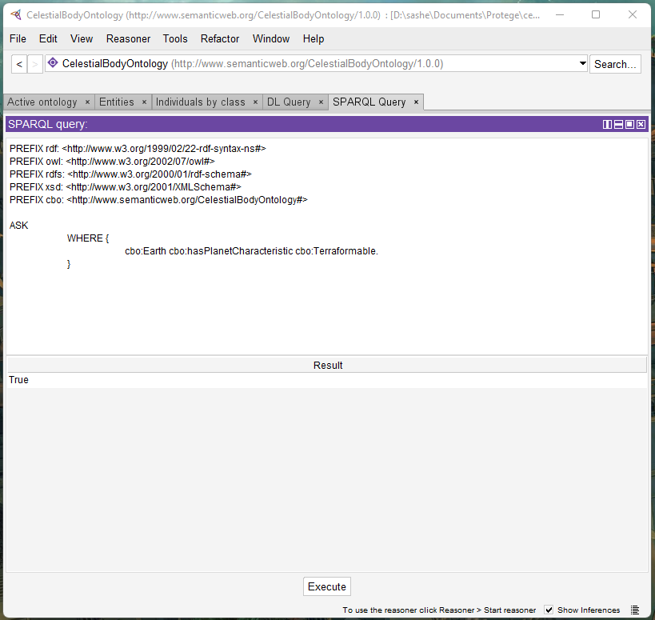

Fig. A31. Is it possible to terraform Earth?

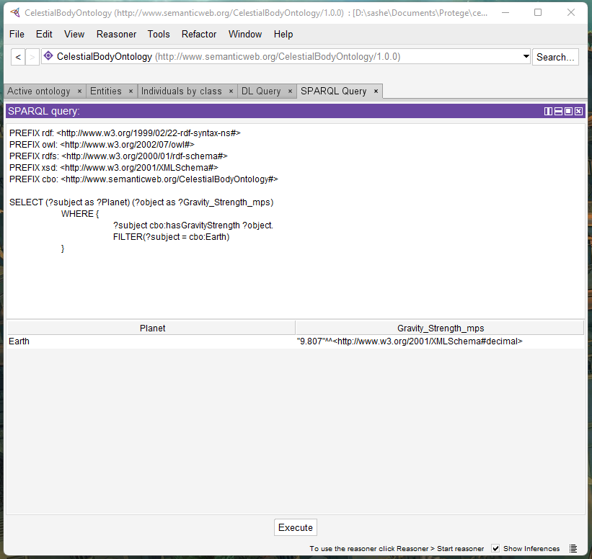

Fig. A32. How strong is the gravity on Earth?

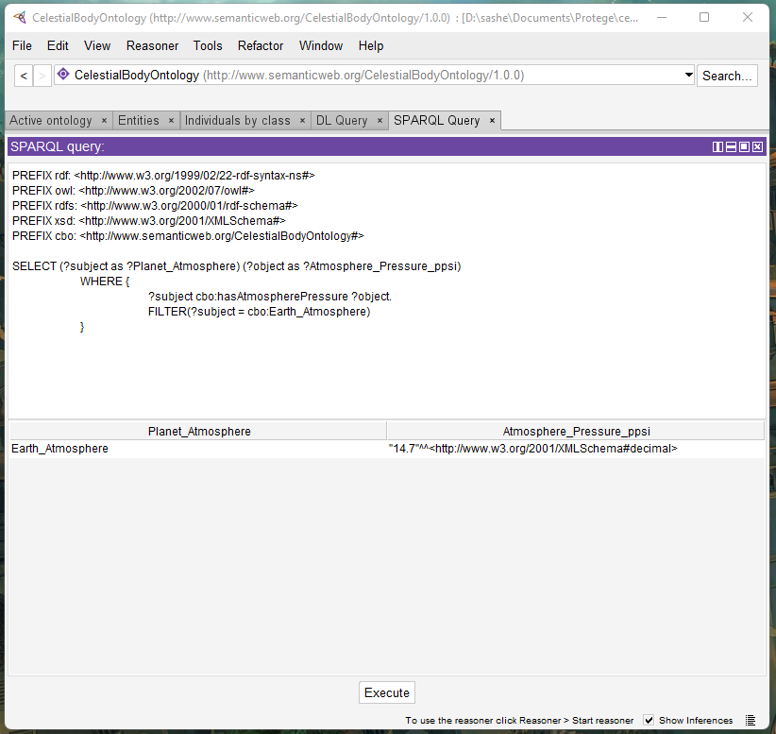

Fig. A33. What is the atmospheric pressure of Earth’s atmosphere?

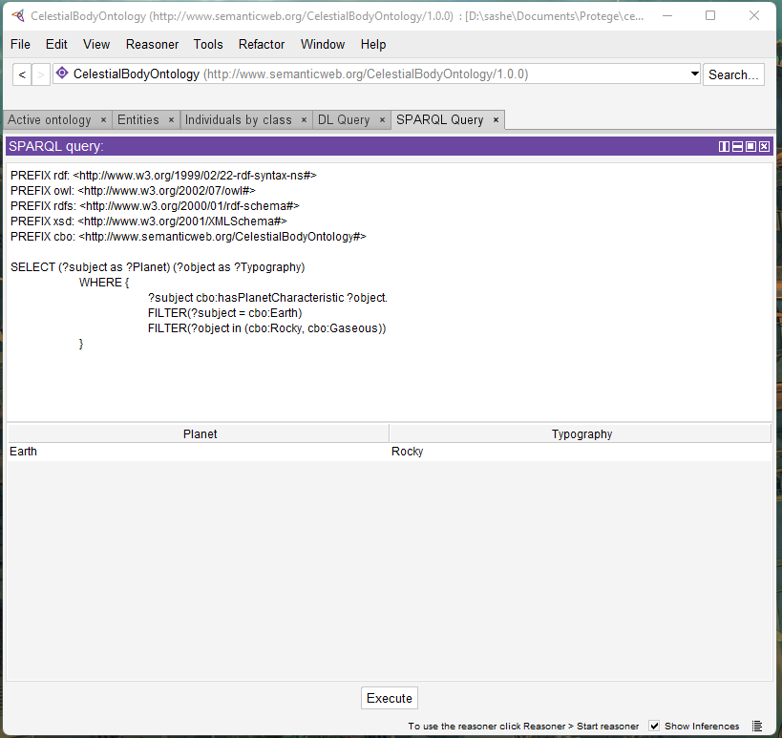

Fig. A34. What is the general typography of Earth?

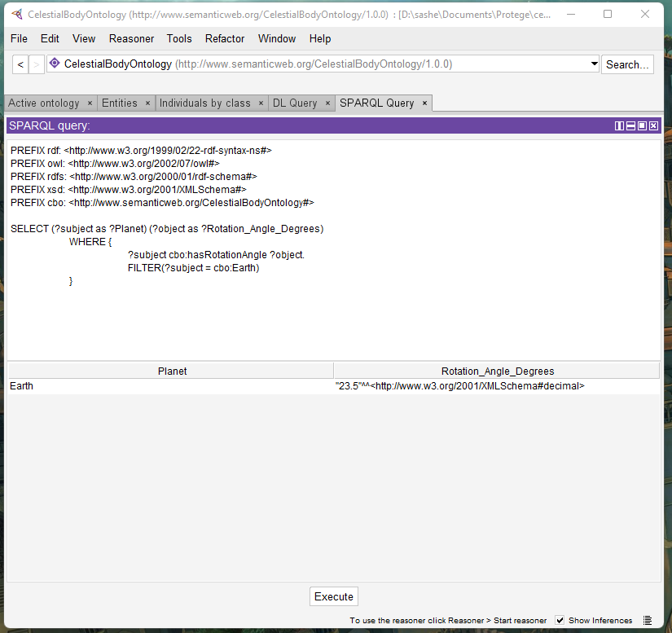

Fig. A35. What is the rotational angle of Earth?

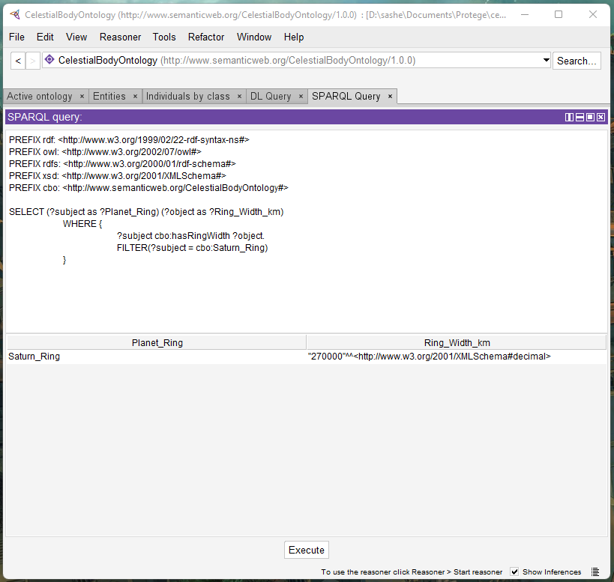

Fig. A36. How wide are the rings of Saturn?

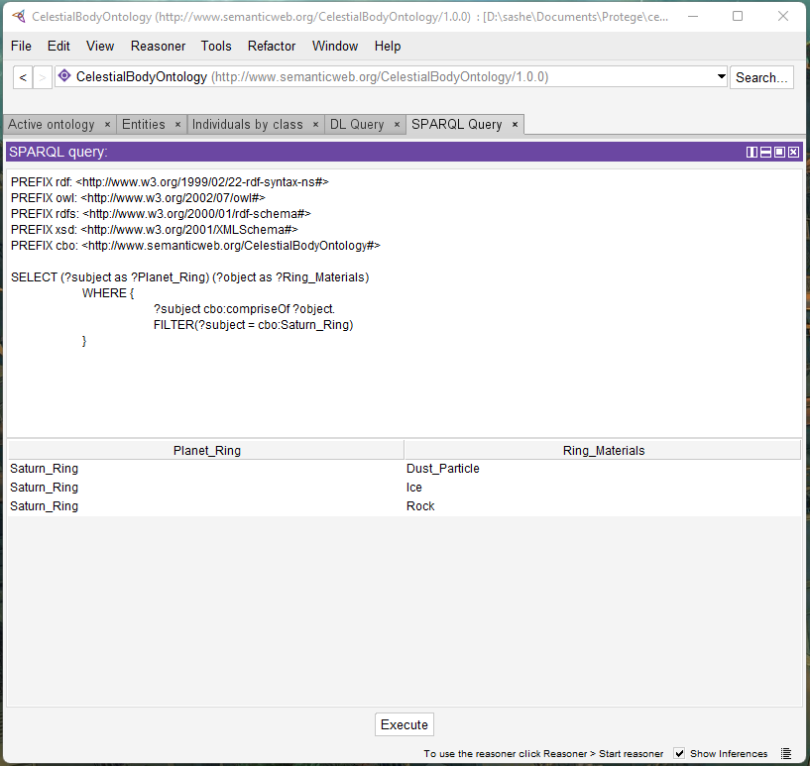

Fig. A37. What materials make up Saturn’s rings?

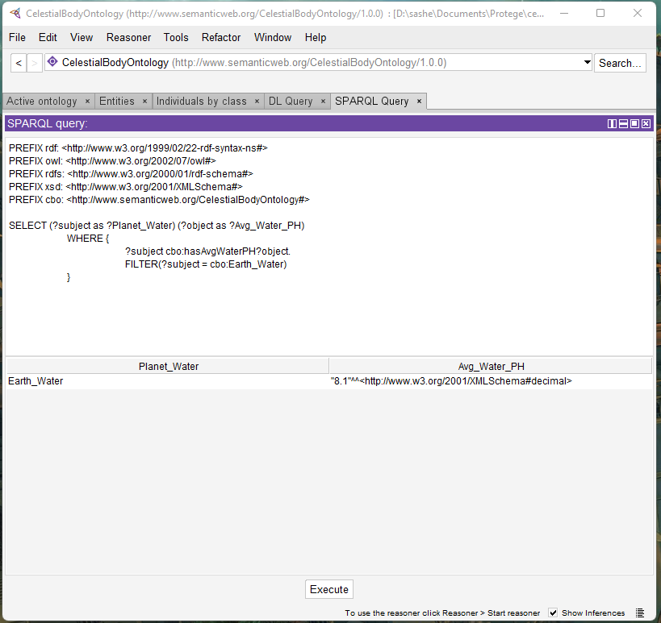

Fig. A38. What is the average PH level found in Earth’s water bodies?

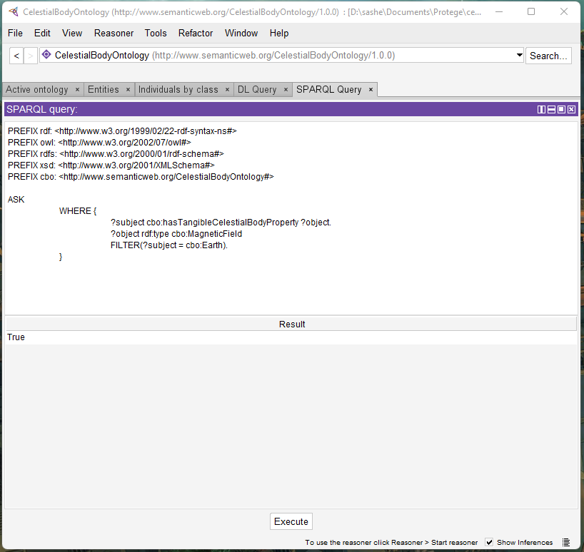

Fig. A39. Does Earth have a magnetic field?

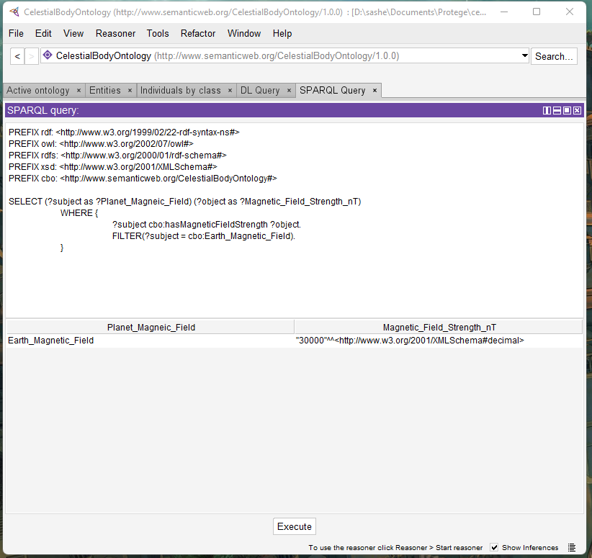

Fig. A40. How strong is the magnetic field of Earth?



Fig. A41. What elements does The Sun produce?

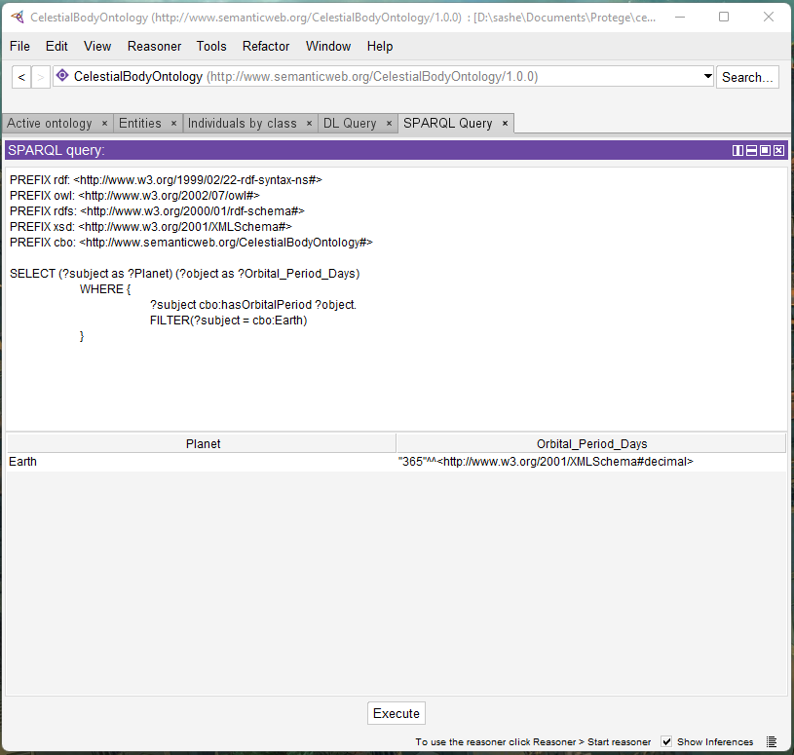

Fig. A42. What is the orbital period of Earth?

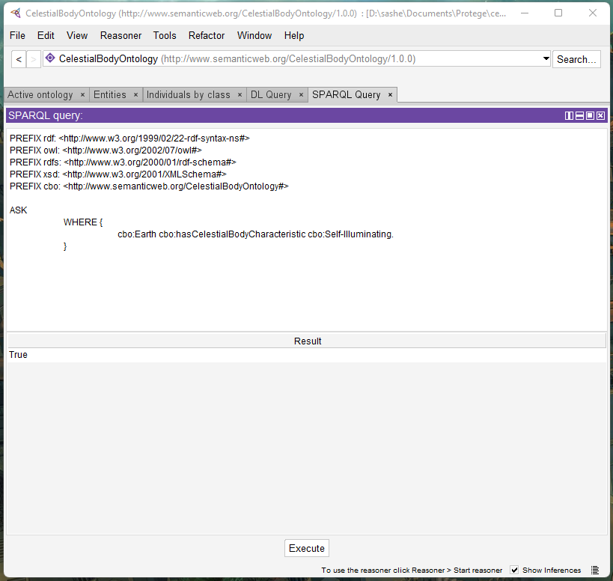

Fig. A43. Is Earth self-illuminated?

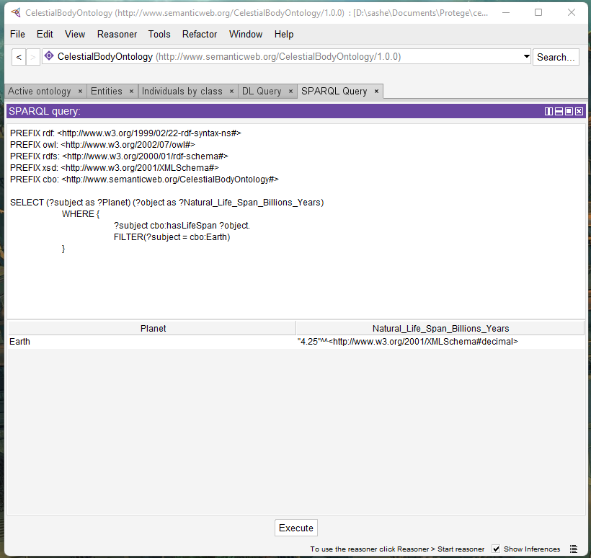

Fig. A44. What is the natural life span of Earth?

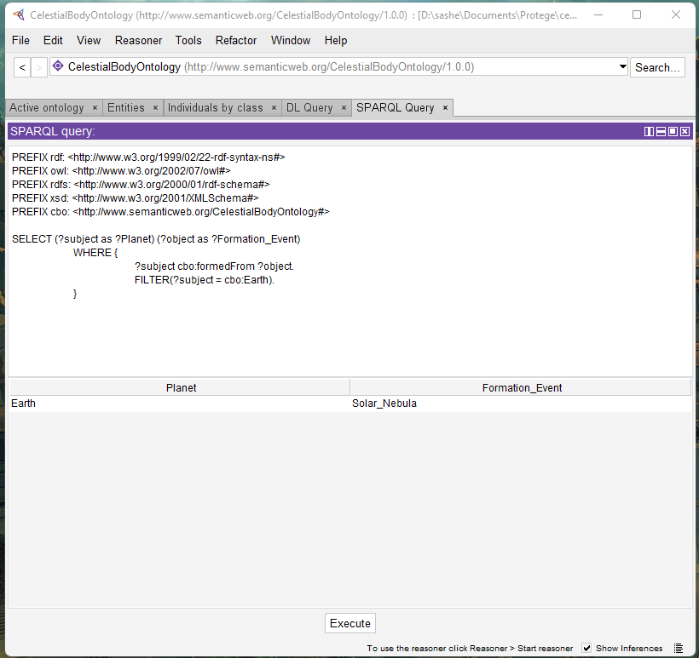

Fig. A45. What formation event created Earth?

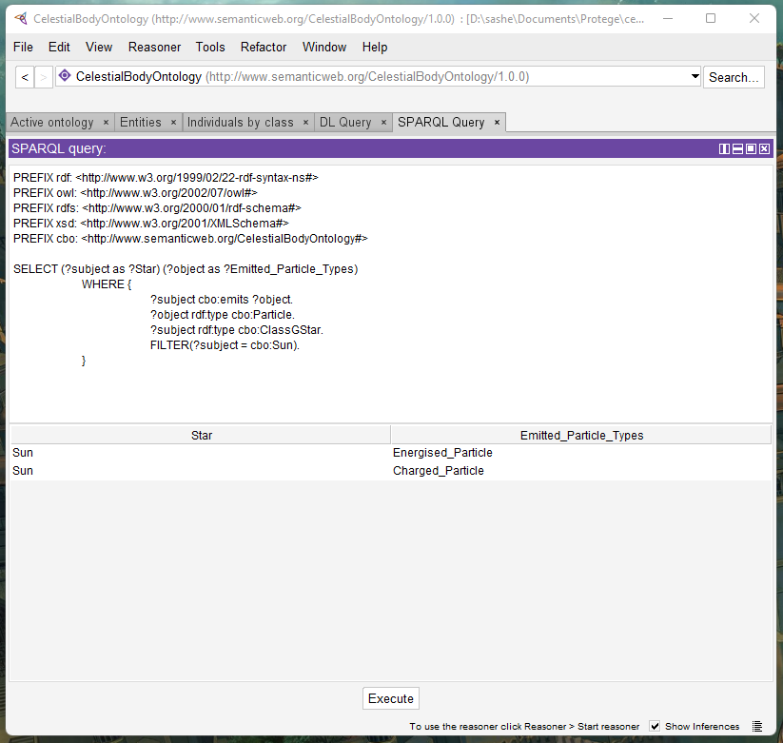

Fig. A46. What particles does The Sun emit?

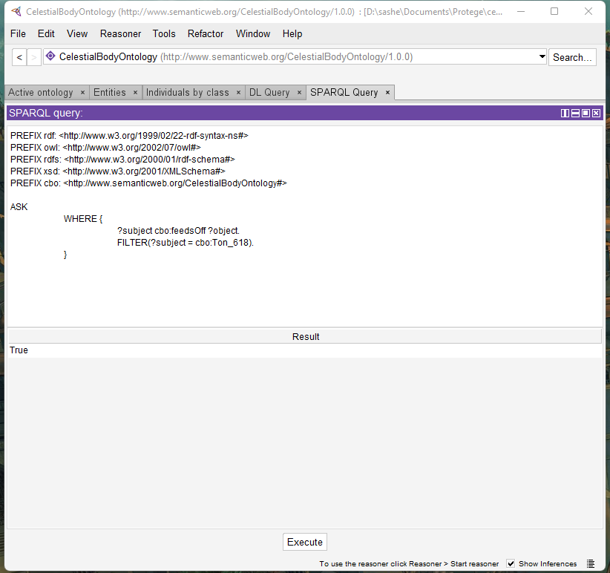

Fig. A47. Does Ton-618 feed off other entities?

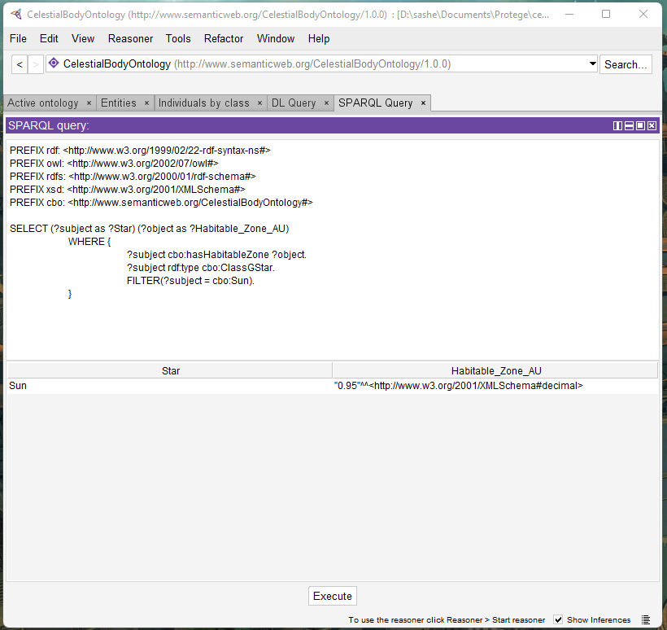

Fig. A48. What is the habitable zone of The Sun?

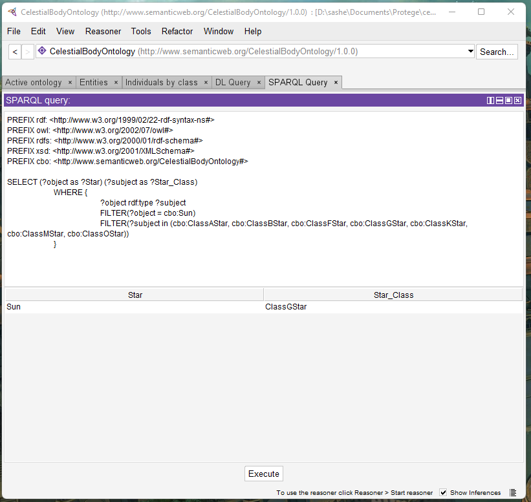

Fig. A49. What type of star is The Sun?

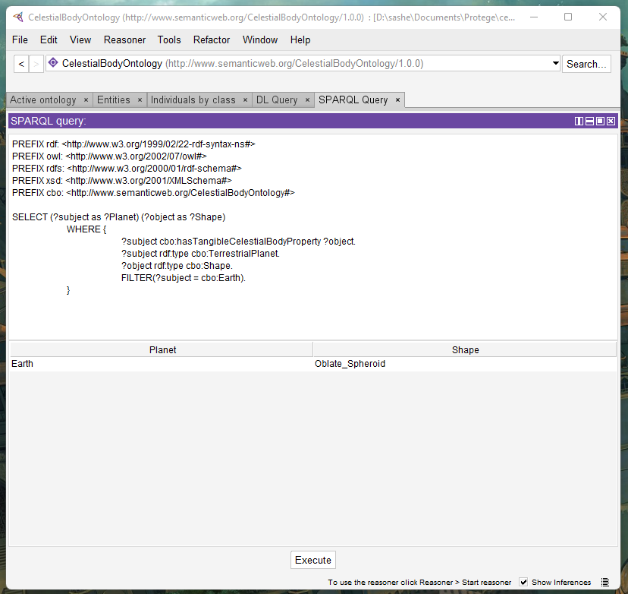

Fig. A50. What is the general shape of Earth?

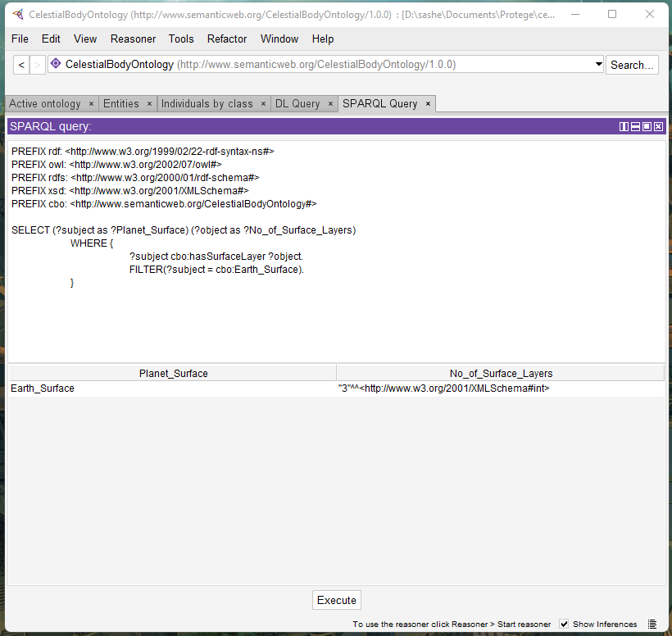

Fig. A51. How many layers does the surface of Earth have?

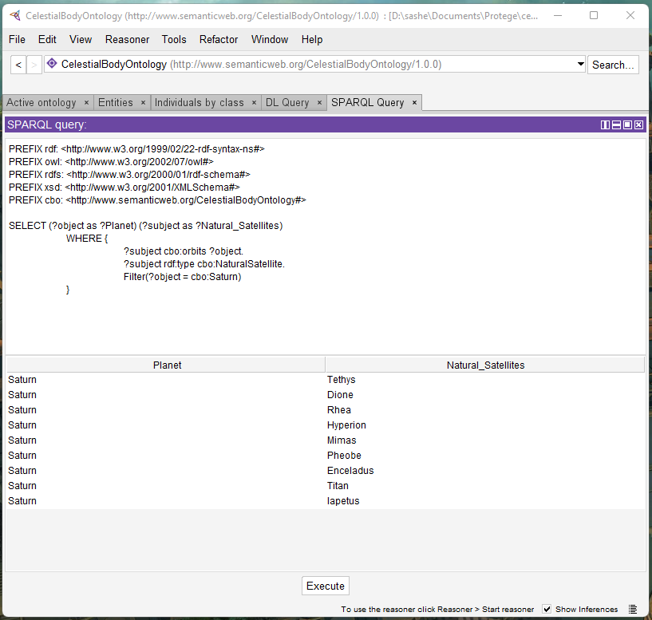

Fig. A52. What are the natural satellites that orbits Saturn?



Fig. A53. What is the largest natural satellite that orbits Saturn, and what is its radius?

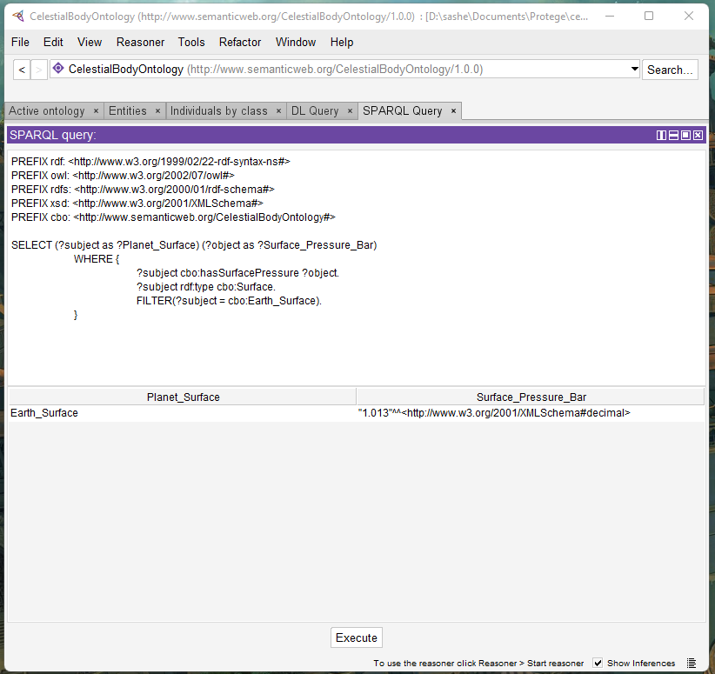

Fig. A54. What is the average surface pressure of Earth’s surface?

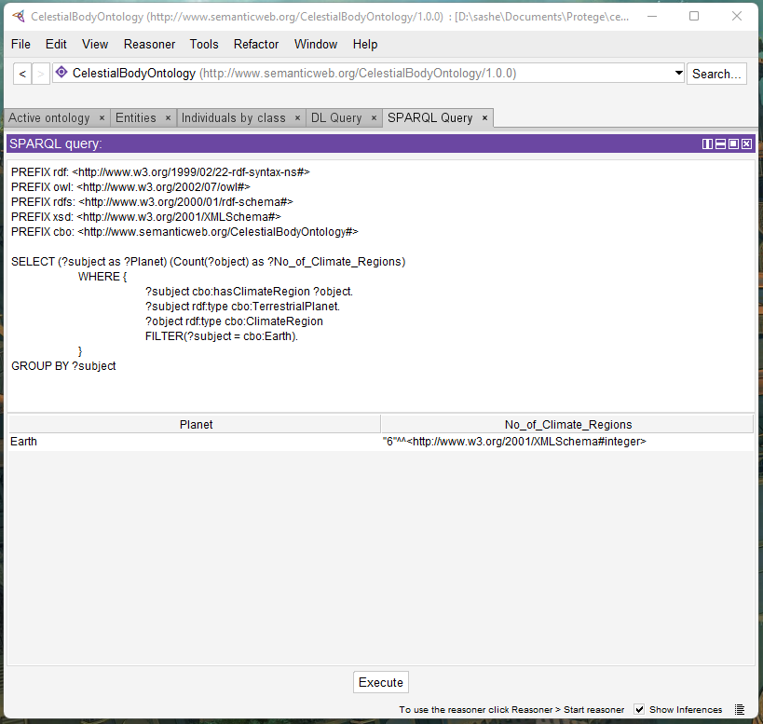

Fig. A55. How many known climactic regions does Earth have?

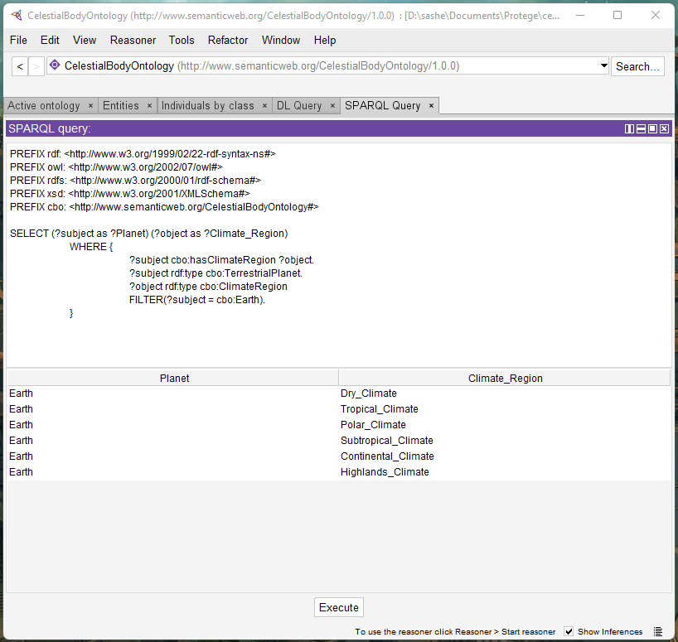

Fig. A56. What are the known climactic regions of Earth?

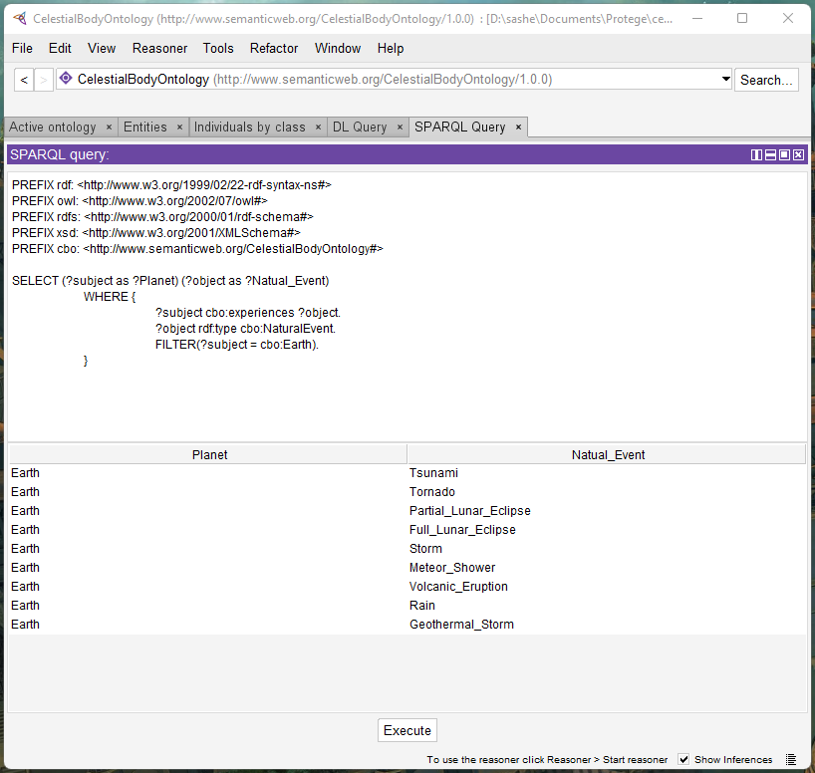

Fig. A57. What natural events does Earth experience?

# Appendix B – Miscellaneous

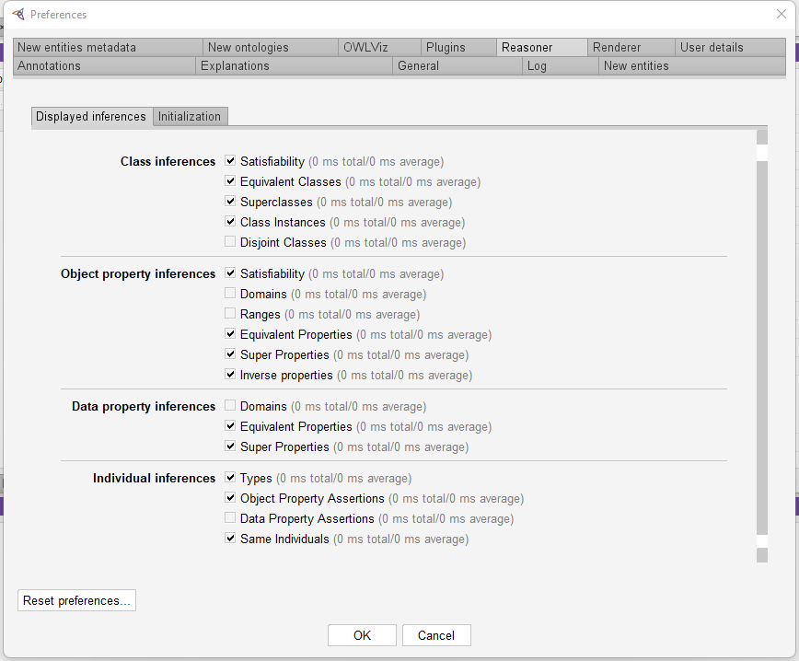

Fig. B1. Configuration of the HermiT reasoner

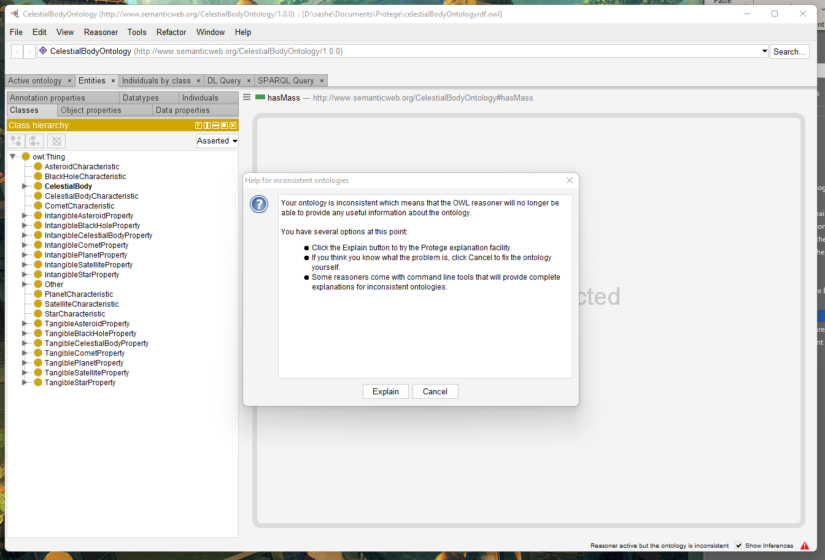

Fig. B2. Example of the pop-up alter that would be shown if the ontology was inconsistent and no inferences could be made (Note: This is just an example; our ontology **does not** receive this message)